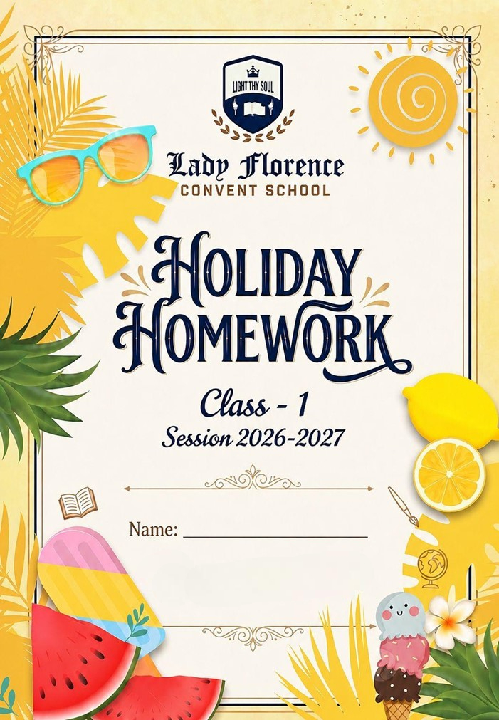
Dear Students

Summer vacation is here! ☀

It’s time to relax, refresh, and enjoy beautiful summer days with your family and friends. May your holidays be filled with happiness, laughter, fun activities, and new experiences.

Use these vacations wisely by reading storybooks, helping your parents, practicing good habits, and exploring your creativity. Don’t forget to complete your holiday homework neatly and on time.

Handwritten Content:
- Ensure all textual work is fully handwritten by the students.
- Visual Elements: Integrate relevant drawings, diagrams, or printed pictures to support findings.
- File Organization: Compile all finished assignments securely inside a clearly labeled folder.

Academic Core & Revision Syllabus
- Revision: Revise all chapters taught prior to the vacation for upcoming tests.
- Mathematical Drills: Practice core mental math worksheets and memorize numerical tables.
- Subject Integration: Complete assigned Subject Enrichment Activities (SEA) like model building or map tracing.

Submission & Evaluation
- Mandatory Status: All vacation homework assignments are compulsory academic components.
- Strict Deadlines: Submit Holiday homework timely.

☀ Health & Routine Guidelines
- Set a Timetable: Budget early morning hours for studying to keep afternoons entirely open.
- Beat the Heat: Avoid playing directly under midday sunshine or in extreme hot spots.
- Stay Hydrated: Drink plenty of fluids, and focus on your diet enriched with nutrient-rich seasonal fruits.
- Screen Time Limits: Restrict daily television viewing and digital gaming to less than one hour.

SUBJECT - ENGLISH
Picture Reading
Q1. Look at the picture carefully and write the answer in the given box.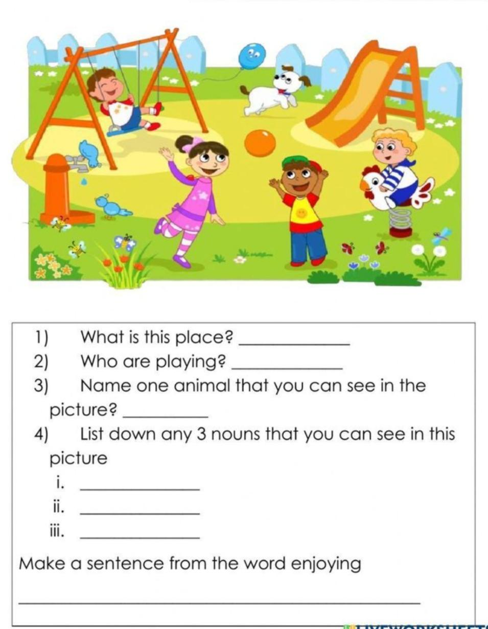
- Write the name of the place.
_____________________________________________________________________
- How many children are playing?
_____________________________________________________________________
- Name one animal that you can see in the picture.
_____________________________________________________________________
- Write down any five nouns that you can see in this picture.
i) _______________
ii) _______________
iii) _______________
iv) _______________
v) _______________
Q2. Read the story carefully and underline the nouns. 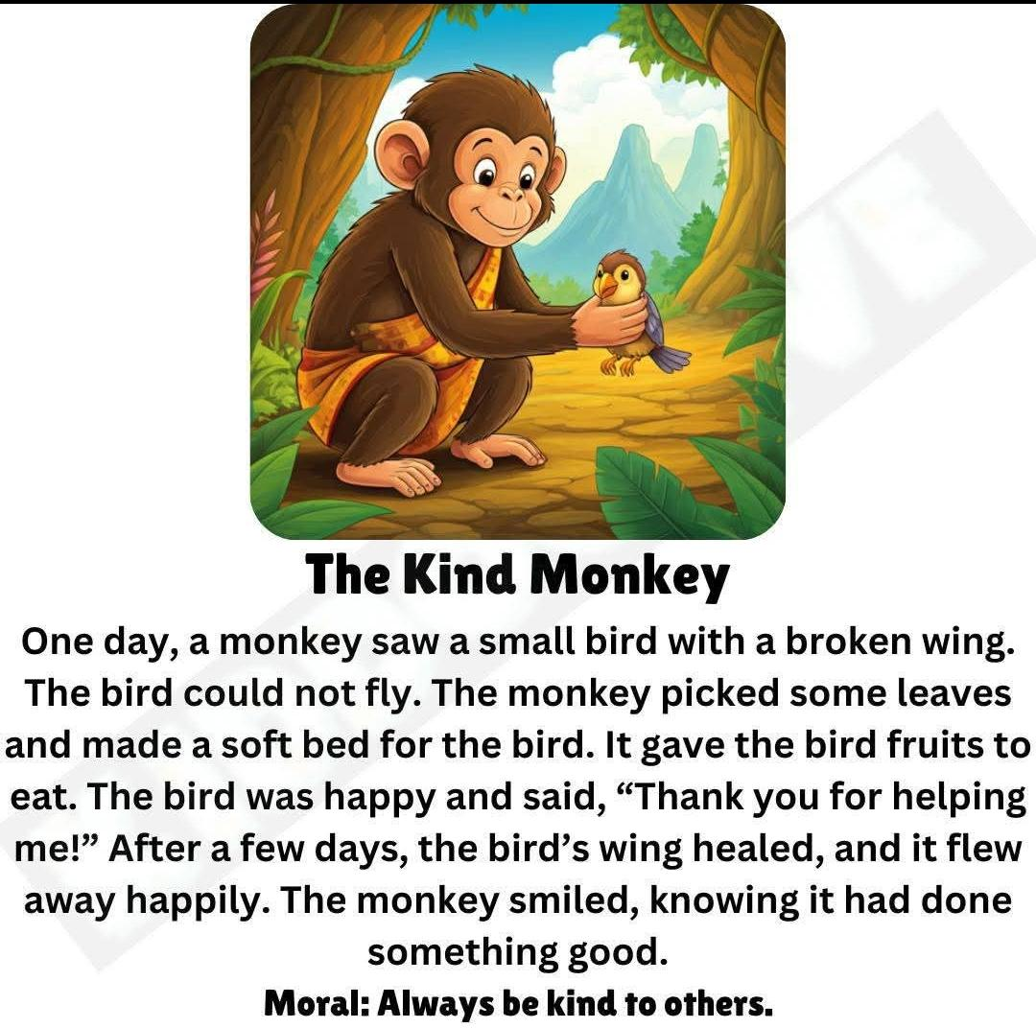
Q3. Look at the picture and circle the correct word.
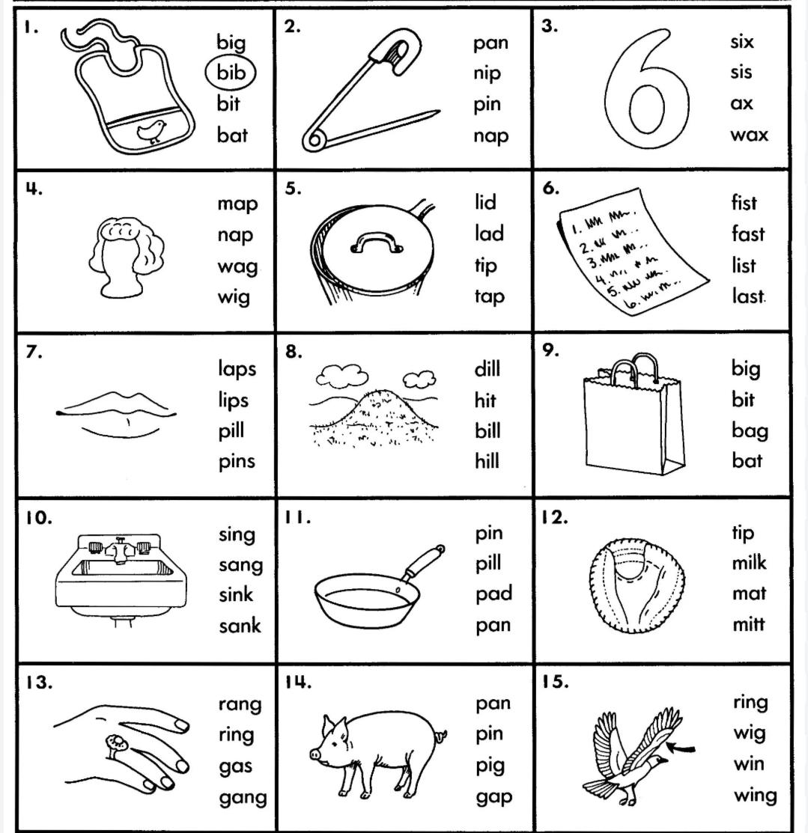
Q4. Colour the correct answer.
i) There is a plate. ________ is white in colour.
- it b. you
ii) Sameer and Riya are friends. _________ play together.
- he b. they
iii) The ____________ stitches clothes.
- tailor b. teacher
iv) Riya has __________hair.
- curly b. wooden

PHONICS WORKSHEET:

SECTION A: SHORT VOWEL SOUNDS (CVC WORDS)
Look at the middle vowel sound. Fill in the blank space with the correct vowel (a, e, i, o, u) to complete the word.
- b ___ g (Hint: Something you carry to school)
- p ___ n (Hint: Used for writing)
- s ___ t (Hint: Action of sitting down)
- h ___ t (Hint: Worn on your head)
- d ___ g (Hint: A loyal pet animal)
- s ___ n (Hint: Shines bright in the sky)

SECTION B: CONSONANT DIGRAPHS (sh, ch, th, wh)
Choose the correct digraph from the box to complete each word pattern.
[ sh | ch | th | wh ]

- ____ ____ i p (Hint: Sails in the ocean)
- ____ ____ i n (Hint: Part of your face below your mouth)
- ____ ____ u m b (Hint: One of your five fingers)
- ____ ____ e e l (Hint: Round part of a bicycle or car)
- ____ ____ o p (Hint: A place where you buy things)

Activity 1- Truthful Hand Craft"

Trace the child's hand on A4 pastel color sheet. On each finger, ask them to write one magical word.
(e.g. "Pardon me", excuse me,please).
Requirements:
A4 pastel sheet - 1
Sketchpen

Note – Complete Page no 2 to 16 in cursive writing book.

SUBJECT - MATHS
Q1. Count and write the correct number in the given circle.
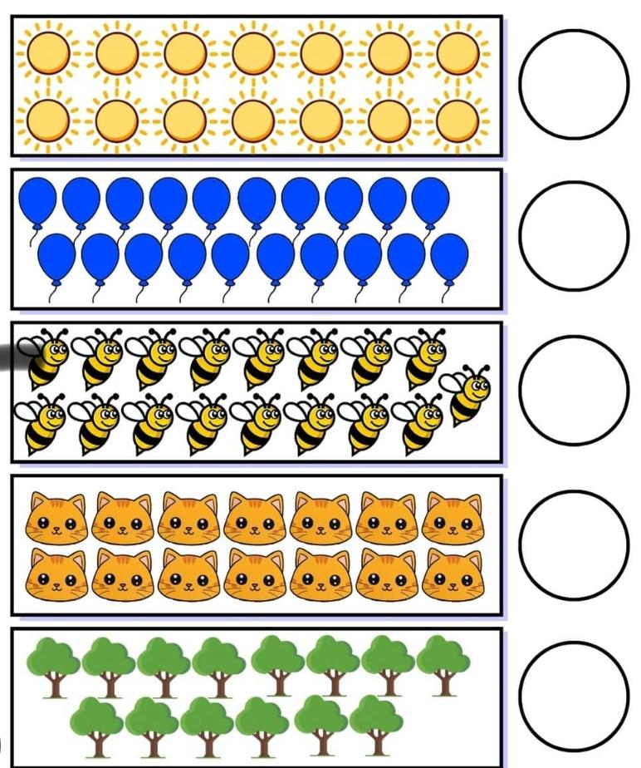

Q2. Find the number name from the given puzzle and circle them.
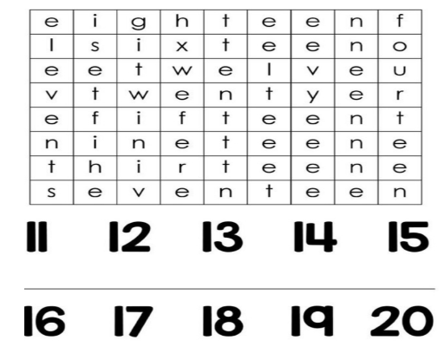
Q3. Write the number names.

a) 13- ____________________

b) 15- _____________________

c) 17- ______________________

d) 19 -______________________

e) 20- ______________________
Q4. Fill in the blanks.

a) + = _______

b) + = __________

c) + = _________

Activity 1 - Big and Small Hunt
Find 5 big and 5 small objects from your home and paste/draw them on a chart paper.

SUBJECT - EVS
Q1 Choose the correct option for each of the following -
i) If you do not use your feet, you will not be able to-
a. run b. hear c. eat
ii) You hear a fire alarm. Which sense tells you to leave the room?
a. eyes b. ear c. nose
iii) Which type of house is yours?
a. kuccha house b. pucca house c. tree house
iv) If anyone touches you in an unpleasant way, it is a _________
a. good touch b. bad touch c. fun
Q2. Fill in the blanks with the correct option.
(bathroom, five, hand, water)
i) We have ___________ sense organs.
ii) Wrist is a part of our ___________.
iii) We take bath in our__________.
iv) We should drink plenty of ___________.

Q3. Tick (√) for good manners and cross (x) for bad manners.
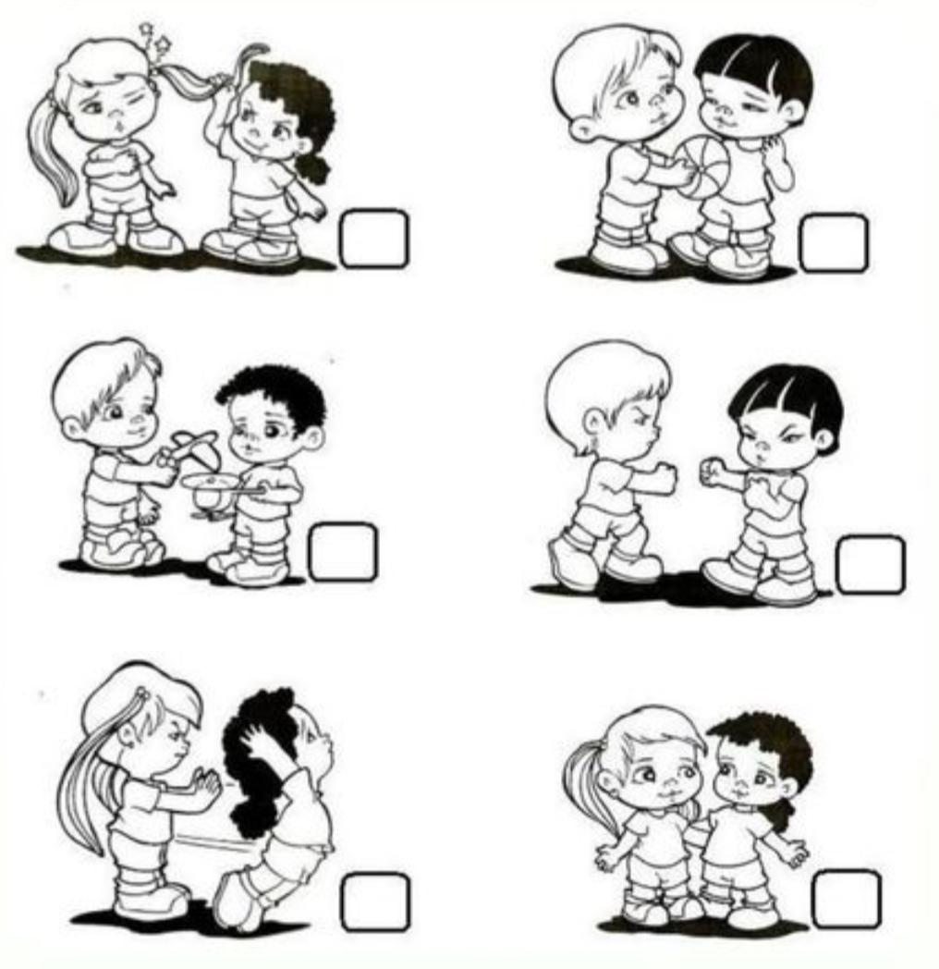
Q4. Draw your favourite fruit or vegetable basket and colour it.

Activity 1 - Sense Detective Journal
Use five senses -
- On the nature walk- Stop and notice
- I see - Draw a tree
- I hear - Draw a bird - write “ chirp chirp”
- I smell - Draw a flower - write “beautiful fragnance“
- I touch - Draw a stone - write ”rough” or “smooth “
Note – Do the above given activity on A-3 size sheet.

Activity 2 - Create a mini model of Kutcha house or Pucca house using waste materials. (cardboard boxes, matchsticks, straw, mud, pebbles)

Note – Kindly refer to the link given below.
https://youtu.be/nP3l5M3lfKE?si=puZLjQ1GF4g9xEua

विषय - हिंदी
प्रश्न 1 दिए गए गद्यांश को पढ़कर पूछे गए प्रश्नों के उत्तर दीजिए :
रवि एक अच्छा बच्चा है। वह रोज सुबह जल्दी उठता है। रवि पेड़-पौधों को पानी देता है। उसे खेलना और पढ़ना अच्छा लगता है। वह सबकी मदद करता है।

निम्नलिखित प्रश्नों के उत्तर लिखें।
- गद्यांश में बच्चे का नाम क्या है?
उ._________________________________________
- रवि कब उठता है?
उ.___________________________________________

- रवि किसे पानी देता है?
उ.____________________________________________

- रवि को क्या अच्छा लगता है?
उ._____________________________________________

- रवि कैसा बच्चा है?
उ.______________________________________________

प्रश्न : 2 बिना मात्रा वाले शब्द खोजो l

तालिका में छिपे शब्द ढूँढो l
क | म | ल | ज | ल
फ | ल | न | ल | घर
ब | स | व | न | मन
र | थ | प | थ | धन
ह | ल | ज | ग | कप

प्रश्न 3 शब्द जोड़कर लिखें।

(क) क + म + ल = _______ (ख) न + ल = _______
(ग) थ + र + म + स = _______ (घ) क + ल + श = _______
(ङ) म + ह +ल =__________ (च) म + ट + र =_______
(छ) क + स + र + त =________ (ज) म + ल + म + ल =________

प्रश्न 4. मेरा परिचय :-
i) मेरा नाम ____________ है।
ii) मैं कक्षा 1 में पढ़ता/पढ़ती हूँ।
iii) मेरे विद्यालय का नाम ____________ है।
iv) मुझे _____________ करना अच्छा लगता है I
v) मेरा घर ________________ में है I

प्रश्न 5 चित्र वर्णन :-
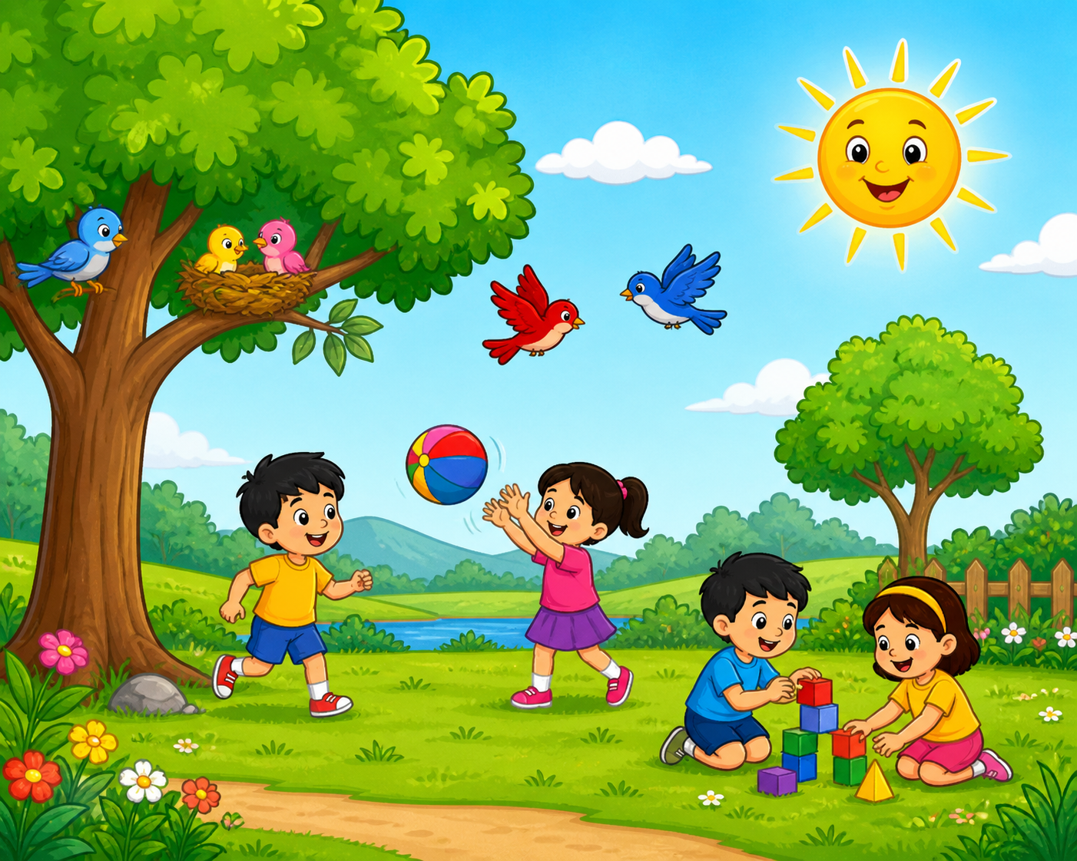

चित्र देखकर 5 वाक्य लिखो।
(पार्क , पेड़ , बच्चे , सूरज , फूल)
  - ______________________________.
  - ______________________________.
  - ______________________________.
  - ______________________________.
  - ______________________________.

गतिविधि (Activity) :-
- स्वर और व्यंजन से संबंधित एक वृक्ष बनाएं जिसमें स्वर और व्यंजन को सजाएँ

- सुलेख अभ्यास – सुलेख पुस्तक में पृष्ठ 1-15 तक करे I

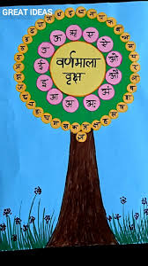

SUBJECT - ART AND CRAFT
Q1. Color the fish as the instructions given below.
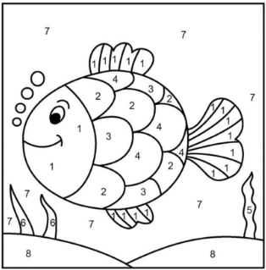

Color Key
- Yellow 3. Orange 5. Light Green 7. Blue
- Red 4. Pink 6. Green 8. Beige

Q2. Do coloring as instructed below.
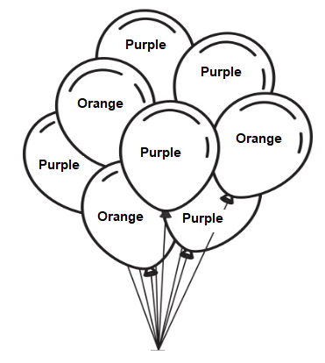

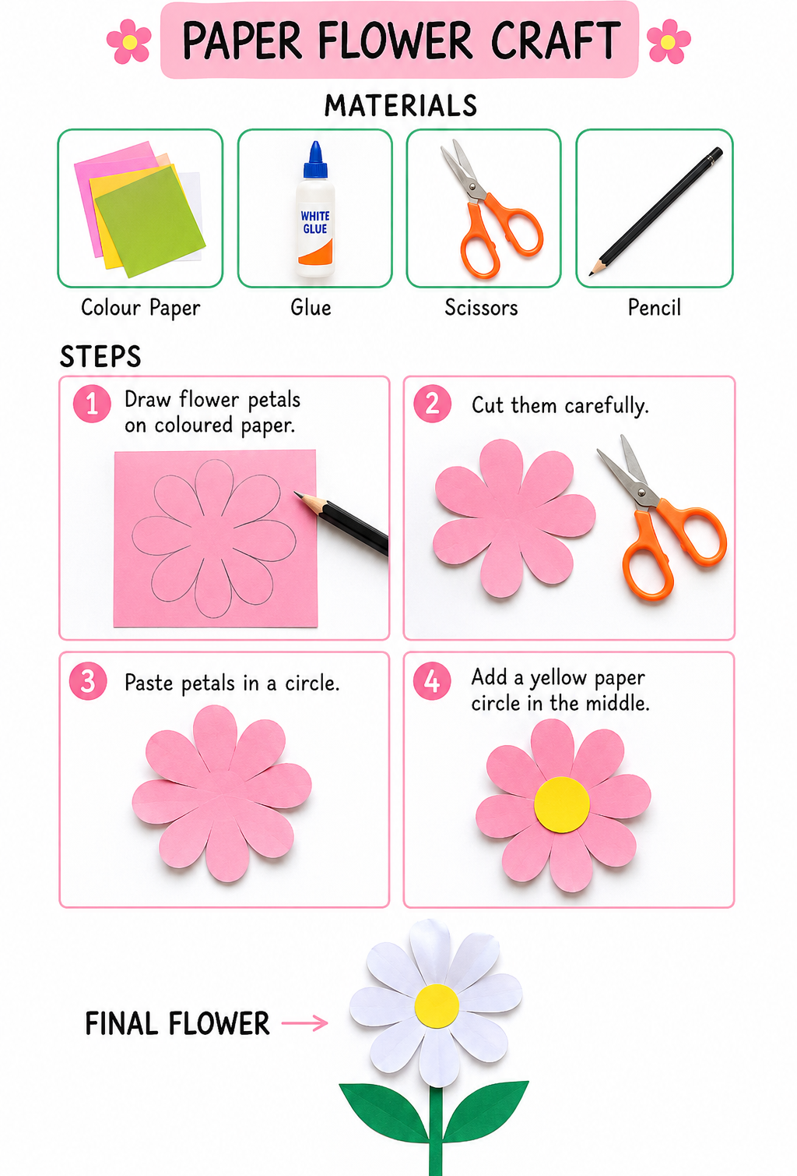

Paper Flower Craft Instructions 🌸

Materials Needed
- Color paper
- Glue
- Scissors
- Pencil
Step-by-Step Instructions:
Step 1: Draw the Petals
Take a coloured paper and draw flower petals using a pencil.

Step 2: Cut the Petals
Carefully cut the petals with scissors.
Step 3: Arrange the Petals
Place all petals in a circle shape to form a flower.
Step 4: Paste the Petals
Use glue to stick the petals on the paper.
Step 5: Make the Centre
Cut a small yellow circle and paste it in the middle of the flower.
Step 6: Add Stem and Leaves
Cut green strips and leaves from green paper and paste them below the flower.
Step 7: Decorate
Decorate your flower craft with colours, glitter, or stickers if you want.

Safety Tips:
- Use safety scissors under parental supervision.
- Neat work to be presented.
- Keep your workspace clean.

SUBJECT - VALUES & LIFE SKILLS ASSIGNMENT

Politeness – “The Three Magic Words: Please, Sorry, Thank You” Read the story:
Aarav wants to borrow his sister’s crayon box. He says, “Give me the crayons now!” His sister feels sad and says no. Mom tells Aarav, “Use magic words” Aarav tries again and says, “Please can I use your crayons?” His sister smiles and says yes!

Tick the correct answer:
  - What should Aarav say to get the crayons nicely?
    - Please can I use your crayons?
    - Give me now!
    - I want it!
  - Why did his sister say yes the second time?
    - Because he took it himself
    - Because he used the word “Please”
    - Because he shouted
  - Which magic word do we say when we make a mistake?
    - Please
    - Sorry
    - Thank you

Patience – “I Wait For My Turn” Read the story:
Riya and Kabir both want to play on the swing. Kabir runs and sits first. Riya feels upset.
The teacher says, “Let’s make a line. Kabir will go first, then Riya.” Riya waits and claps when it’s her turn. She enjoys the swing more!

Tick the correct answer:
- What should Riya do when Kabir is on the swing?
  - Push him off
  - Cry and go home
  - Wait for her turn Cry and go home
- Why is waiting for your turn good?
  - It makes others angry
  - It keeps everyone happy and safe
  - It is boring
- What can you say when you wait?
  - “It’s mine now!”
  - “I will wait for my turn.”
  - “No!”

Kindness & Sharing – “The Lunchtime Surprise” Read the story:
During lunch, Anaya has extra biscuits. Her friend Rohan forgot his tiffin and looks sad.
Anaya says, “Rohan, you can have half of my biscuits.” Rohan smiles and says, “Thank you!” Both feel happy.

Tick the correct answer:
  - What did Anaya do for Rohan?
    - Took his water bottle
    - Shared her biscuits
    - Ignored him
  - How did Rohan feel after Anaya shared?
    - Sad
    - Happy
    - Angry
  - What do we say when someone shares with us?
    - No
    - Go away
    - Thank you

Activity: Share & Care
- Draw a picture of you sharing something with someone:

NOTE: Holiday homework should be submitted on the first day after the school
reopens.

