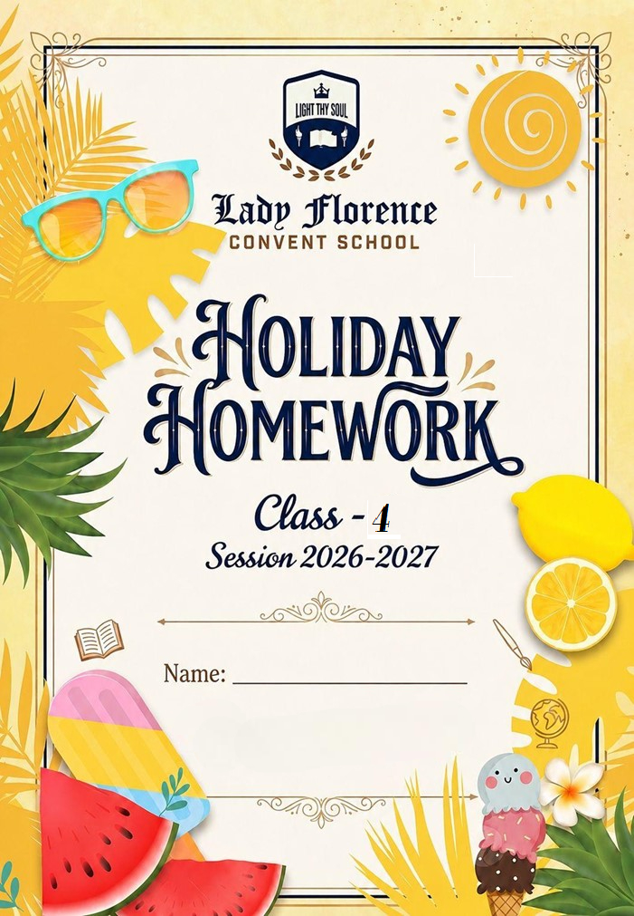

General Instructions:
Dear Students,

Vacations are not just about rest—they are a perfect time to reconnect with your loved ones and focus on your personal growth. Set a goal for yourself and make every day count as you move closer to achieving it!

For students:-

      - Do your vacation work by yourself.
      - Submit all home work on the first day after the summer break.
      - Use separate Note book for each subject.
      - Writing should be very good and neat.
      - Complete your written work regularly to enhance your writing power.
      - Pay special attention towards your health and well-being
      - Don’t play in the sunshine.
      - Start your day with meditation and physical exercise.

For Parents:-
      - Make your ward read resource books.
      - Do any creative act, which you are good at with your ward and if possible send it to school after vacations.
      - Fix up a time table for your ward to organize his/her daily routine like, watching television, playing with friends, studying etc.
      - Make your child responsible by assigning some of the household responsibilities to him/her like, watering plants, arranging the dining table, organizing his/her room and cupboards, fill the empty water bottles and put them in refrigerator.

Above mentioned guidelines will help your child to become a smart and an active learner.

Let this vacation be a time of joy, creativity, learning, and togetherness!
Have a wonderful and productive holiday!



ENGLISH

ACTIVITY 1.
“The Lion and the Little Mouse Comic Strip”
Instructions: Imagine a day in the life of a Lion and a Mouse from the story “The Lion and the Little Mouse.” Create a comic strip with at least 4 frames showing their adventure, teamwork, and friendship.
Use speech bubbles, drawings, and a title. You may use coloured pencils, sketch pens, or even make it using digital tools.
Skills Developed: Creative writing, imagination, and sequencing.
Objective: To interpret the moral of the story through creativity.
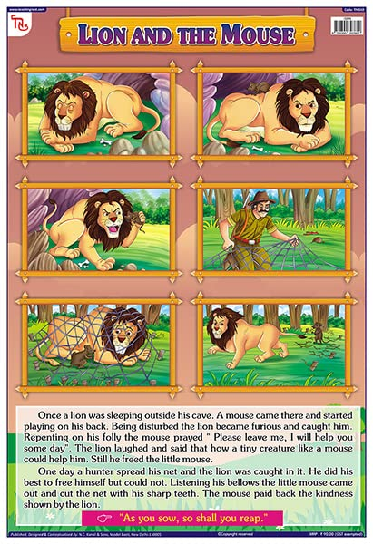

Task A: Word Meanings & Sentences
Look up the meaning of each word in the dictionary and write a sentence using it.
- Enormous
- Whisper
- Ancient
- Exhausted
- Glimmer
- Peculiar
- Fierce
- Graceful
- Hesitate
- Vibrant

Task B: Odd One Out
Circle the word that does NOT belong to the group and write why:
- Happy joyful sad cheerful
- Rose tulip daisy mango
- Run walk sleep jog
- Honest brave kind lazy
- Ocean river mountain lake

TASK 2 — WORD PUZZLE

Task: Find the Hidden Words!
Jumbled Words (Action Words / Verbs)
- NUJMP → ____
- NIGS → ____
- DNCAE → ____
- RNU → ____
- ALPY → ____
- TALWK → ____
- TEAS → ____
- KLAET → ____
- SLEPE → ____
- HGLUA → ____
TASK 3 — CREATIVE WRITING
Task A: Story Starters (Choose ONE)
Read the story starter and continue the story in at least 8–10 sentences. Give your story a title.
Starter 1: "It was the strangest summer morning. When I woke up, my room was filled with glowing butterflies — and one of them spoke to me…"

Starter 2: "During the summer holidays, I found an old, dusty map in my grandmother's attic. At the bottom it read: 'Follow the steps to find the hidden treasure'…"

Title of my story: _______________________________________________

Task B: Postcard to a Friend
Imagine you are on a summer holiday trip. Write a postcard (6–8 sentences) to your best friend describing where you are, what you see, and how you feel. Paste that postcard in your scrap book.

Message:

To:
Address:
[Stamp]

TASK 4 — READING LOG
Task: My Summer Reading Adventure
Read at least ONE storybook book of your choice this summer and fill in the reading log below.
- Title of the Book
- Name of the Author
- Main Characters
- Setting (Where & When)
- What is the story about? (2–3 sentences)
- My favourite part of the story
- A new word I learnt from the book
- I would rate this book: (circle)

TASK 5 — SYLLABUS REVISION SHEET
Answer the following questions based on the syllabus covered in April and May.
Q.1 Fill in the blanks with the correct form of the verb:
- She _____________ (sing) a beautiful song every morning.
- They _____________ (play) football when it started to rain.
- I _____________ (finish) my homework before dinner.
- The birds _____________ (fly) south every winter.
- He _____________ (not, eat) his lunch yet.

Q.2 Rewrite the following sentences after correcting the errors:
- She don't likes to eat vegetables.
- The childrens are playing in the garden.
- I have saw that movie last week.
- He goed to the market yesterday.
- They is my best friends.

Q.3 Read the passage and answer the questions below:
The Amazon rainforest is often called the 'lungs of the Earth' because it produces about 20% of the world's oxygen. Millions of animals and plants live there. However, every year large parts of the forest are cut down for farming and roads. This threatens the habitat of thousands of species. Scientists say we must act now to protect this precious ecosystem before it is too late.
  - Why the Amazon rainforest is called the 'lungs of the Earth'?
  - What threat does the forest currently face?
  - Find a word from the passage that means 'important and valuable'.
  - What do you think should be done to protect forests? (Write 2–3 lines.)
Q.4 Write antonyms (opposites) for these words:
- brave
- expand
- ancient
- generous
- victory

Q.5 Write a paragraph (5–6 sentences) on any ONE topic:
- My favourite season
- A visit to a zoo / museum / park
- The importance of trees

Topic I chose: _____________________________________

TASK 6 — READING CHALLENGE ⭐ (Bonus)
Read a book of your own choice this summer! Pick any fiction / children's novel / kids' storybook you love. After reading, complete the activities below.
Need ideas? Here are some wonderful books to choose from:
- Funny & Adventure
- Fantasy & Magic
- Feel-Good Stories
- Diary of a Wimpy Kid– Jeff Kinney
- The Magic Tree House Series– Mary Pope Osborne
- Charlotte's Web– E.B. White
- Captain Underpants– Dav Pilkey
- The BFG– Roald Dahl
- Stuart Little– E.B. White
- My Father's Dragon– Ruth Stiles Gannett
- Matilda– Roald Dahl
- The Hundred Dresses– Eleanor Estes

Task A: My Book Passport
Fill in the details of the book you read:
- Book Title
- Author
- Genre (tick one): Fiction / Fantasy / Adventure / Funny / Other: ______
- Number of pages / chapters read
- My reading period (from ___ to ___)
Task B: Mini Book Review (Write 6–8 sentences)
Would you recommend this book to a friend? Write a short review saying what you liked (or didn't like) and why others should read it.

Task C: Illustrate Your Favourite Scene
Read a book on your own choice of your favourite writer and draw your favourite scene or character from the book and write a caption for it.
[Draw here]
Caption: _______________________________________________

हिंदी
ग्रीष्म कालीन अवकाश कार्य जमा करने के निर्देश :-
- विद्यार्थी अपना सम्पूर्ण हिंदी विषय का अवकाश कार्य एक ही फोल्डर/फाइल में सुव्यवस्थित रूप से तैयार करें।
- फोल्डर को सुंदर तरीके से सजाएँ तथा उस पर निम्न विवरण स्पष्ट रूप से लिखें:
विद्यार्थी का नाम -
कक्षा एवं सेक्शन -
रोल नंबर -
विषय – हिंदी
- सभी वर्कशीट, प्रोजेक्ट तथा गतिविधियों को क्रमबद्ध तरीके से लगाएँ।
- सभी विद्यार्थियों को अपना फोल्डर ग्रीष्मावकाश के बाद विद्यालय खुलने के प्रथम दिन जमा करवाना अनिवार्य है।

अभ्यास-पत्र-1
प्रश्न-1 निम्नलिखित प्रश्नों में उचित विकल्प पर ( V) निशान लगाइए-
(1) गाँव का राजा कौन बनना चाहता था?
(i) सरपंच (ii) कीटासुर (iii) मेघा
(2) साबुन इस्तेमाल करने की सलाह दी-
(i) कीटासुर ने (ii) सरपंच ने (iii) मेघा
(3) कीटासुर कौन था?
(i) एक साँप (ii) एक (iii) एक जानवर
(4) कोयल कैसे स्वर में गाती है?
(i) मीठे (ii) फीके (iii) कड़वे
(5) कविता में मीठी बोली बोलने के लिए किसे कहा जा रहा है?
(i) कोयल को (ii) पेड़ों को (iii) बच्चों को
(6) कविता में पंचम सुर में कौन गा रहा है?
(i) सूरज (ii) कोयल (iii) बच्चे

प्रश्न -2 बॉक्स में से उचित शब्द का प्रयोग करके खाली स्थान भरिए।
( कीटासुर, सरपंच, हमला , साबुन, कीटाणुओं )
  - कृष्णपुरम का _____________ बहुत नेक और जनप्रिय व्यक्ति था।
  - वहाँ_______________नामक एक वायरस आया।
  - उसने__________ की एक सेना बनाई।
  - कीटाणुओं ने लोगों पर____________कर दिया।
  - सभी लोग_______________से नियमित रूप से हाथ धोएँगे।

प्रश्न - 3 सही कथन पर (✓) का निशान और गलत कचन पर (×) का निशान लगाइए।
  - कीटासुर ने कीटाणुओं की एक सेना बनाई थी।
  - कृष्णपुरम पर कीटाणुओं में हमला नहीं किया था।
  - कोटासुर कृष्णपुरम से दबे पाँव भाग गया था।
  - कोयल डाली हाली फिरती है।
  - कोयल को गाना गाने के लिए हारमोनियम और तबले की जरूरत होती है।
  - पत्तों में छिपकर कौआ गाना गाता है।

प्रश्न - 4 दिए गए शब्दों के अर्थ लिखें -
- हमला ______________ (iv) मेहनत______________
- तरकीब_____________ (v) समा_______________
- जाड़ा_______________ (vi) गरमाता____________

प्रश्न – 5 दिए गए प्रश्नों के उत्तर दीजिए -
- कृष्णपुरम गाँव का सरपंच कैसा आदमी था? _________________
- कीटासुर ने एक बड़ी क्या बनाई थी? __________________
- किसने गाँव वालों को सफाई रखने की सलाह दी? _________________
- कोयल कहाँ छिपकर गाती है? __________________
- कोयल क्या करती फिरती है? __________________
- कोयल नया गीत कहाँ गाती है? ________________

अभ्यास-पत्र-2
(व्याकरण)
प्रश्न-1 दिए गए गद्यांश को पढ़कर पूछे गए प्रश्नों के उत्तर दीजिए।
गाँव का जीवन सादगी और परिश्रम से भरा होता है। यहाँ के लोग प्रकृति के साथ घुलमिल कर रहते हैं। सुबह सूरज निकलते ही किसान खेतों की ओर निकल पड़ते हैं और दिनभर मेहनत करते हैं। गाँव की मिट्टी, पेड़-पौधे और पशु सभी ग्रामीणों के जीवन का अभिन्न अंग हैं। शाम होते ही लोग काम से लौटकर आपस में मिलते-जुलते हैं और दिनभर की बातें साझा करते हैं। गाँवों में त्योहार और मेलों का विशेष महत्व होता है जो लोगों को एकता और आनंद का अनुभव कराते हैं।
(1) गाँव के लोग किसके साथ घुलमिल कर रहते हैं?
i. शहर के लोगों के साथ ii. प्रकृति के साथ iii.मशीनों के साथ
(2) किसान खेतों की ओर कब निकलते हैं?
i. दोपहर में ii. रात में iii सूरज निकलते ही
(3) गाँव के जीवन की मुख्य विशेषता क्या है?
i. विलासिता ii. सादगी और परिश्रम iii.व्यापार
(4) गाँवों में मेलों और त्योहारों का क्या महत्व है?
i. वे समय की बर्बादी हैं
ii. वे लोगों को एकता और आनंद का अनुभव कराते हैं
iii. वे केवल बच्चों के लिए होते हैं
(5) ग्रामीण लोग शाम को क्या करते हैं?
i. टीवी देखते हैं ii. खेलते हैं iii. शहर जाते हैं

प्रश्न-2 निम्नलिखित प्रश्नों में उचितविकल्प पर ( V) निशान लगाइए-
(1) ‘ हिमालय ' कौन-सी संज्ञा है?
(i) जातिवाचक (ii) व्यक्तिवाचक (iii) भाववाचक
(2) इनमें से 'भाववाचक' संज्ञा शब्द चुनिए:
(i) मिठास (ii) आम (iii) लड़का
(3) प्रश्नसंज्ञा के मुख्य रूप से कितने भेद माने जाते हैं?
(i) दो (ii) तीन (iii) चार
(4) वर्णों के सार्थक मेल को क्या कहते हैं?
(i) वाक्य (ii) शब्द (iii) वर्णमाला
(5) 'अनपढ़' शब्द में उपसर्ग क्या है?
(i) अ (ii) अन (iii) पढ़
(6) 'फलवाला' में मूल शब्द क्या है?
(i) वाला (ii) फल (iii) फ

प्रश्न - 3 सही कथन पर (✓) का निशान और गलत कचन पर (×) का निशान लगाइए।
(1) किसी व्यक्ति, वस्तु, स्थान या भाव के नाम को संज्ञा कहते हैं।
(2) भाववाचक संज्ञाओं को हम छू नहीं सकते, केवल महसूस कर सकते हैं ।

(3) संज्ञा को नाम वाले शब्द भी कहा जाता है।
(4) शब्दों का कोई न कोई अर्थ होना ज़रूरी है।
(5) 'कमल' एक सार्थक शब्द है।

प्रश्न- 4 रिक्त स्थान भरिए -
(1) रोहन बाज़ार जा रहा है, इसमें 'रोहन' ________________संज्ञा है ।
(2) बुढ़ापा ________ संज्ञा का उदाहरण है।
(3) शब्द के आरंभ में जुड़ने वाले शब्दांश ________ कहलाते हैं।
(4) जिनका कोई अर्थ नहीं होता, वे ________ शब्द कहलाते हैं।
(5) शब्द के अंत में जुड़ने वाले शब्दांश ________ कहलाते हैं।
(6) 'हार' शब्द में 'वि' उपसर्ग लगाने पर ________ शब्द बनेगा।

प्रश्न -5 दिए गए शब्दों के विलोम शब्द लिखें -
(1) सुगंध ____________ (2) ऊपर______________
(3) पास_______________ (4) सच्चा_____________
(5) सत्य______________ (6) आकाश____________
(7) दिन______________ (8) कठिन___________

हिन्दी गतिविधि-
🌸 “मेरी शब्द-खोज थाली” 🌸
उद्देश्य :शब्द भंडार बढ़ाना
सामग्री :
📌 पेपर प्लेट / A4 शीट
📌 पुराने समाचार पत्र / पत्रिकाएँ
📌 गोंद, कैंची, रंगीन पेंसिलें
निर्देश :
एक पेपर प्लेट लें या A4 शीट पर बड़ा गोला बनाइए।
उसे 5 भागों में बाँटिए।
प्रत्येक भाग में ये शीर्षक लिखिए :
📍 फल 📍 सब्जियाँ
📍 जानवर 📍 रंग
⭕ क्रिया शब्द
- समाचार पत्रों या पत्रिकाओं से हिन्दी शब्द या चित्र खोजकर
चुने गए शब्दों में से किसी 5 शब्दों का प्रयोग करके A4 शीट पर 2 वाक्य लिखिए।
उदाहरण :
🖋️ आम पीला फल है। 🖋️ घोड़ा तेज दौड़ता है।

पठन कार्य -
​अपनी पसंद की कोई भी एक कहानी की किताब पढ़े तथा कक्षा में आकर अपना अनुभव साँझा करें।
​ पंचतंत्र की कहानियाँ (विष्णु शर्मा):

MATHS

Q1: Arrange the following numbers in columns and add.
(i) 3,45,787 and 4,52,263
(ii) 25,839 and 60,653
(iii) 4,00,256 , 1,26,543 and 3,098
(iv) 36,23,894 , 40,35,693 and 1,56,954
Q2: Arrange the following numbers in columns and subtract.
(i) 9,45,787 and 4,52,263
(ii) 75,839 and 60,653
(iii) 4,00,256 and 3,098
(iv) 36,23,894 and 1,56,954
Q3: Arrange the following numbers in columns and multiply.
(i) 45,787 and 263
(ii) 75,839 and 153
(iii) 4,256 and 98
(iv) 3,694 and 54
Q4: Divide the given questions and check the answers.
(i) 95,787 ÷ 150
(ii) 55,839 ÷ 156
(iii) 4,56,268 ÷ 18
(iv) 3,64948 ÷ 64
Q5: What is 2805 more than 6412?
Q6: Find the sum of the smallest 4-digit number and the smallest 3-digit number.
Q7: What is 2805 more than 6412?
Application Based Questions.
- The cost of a chair: A school buys 45 chairs for a new classroom. If the cost of one chair is ₹415, what
is the total cost of all the chairs?
- Daily savings: A person saves ₹350 every month. How much money will they save in 12 months?
- Price of bicycles: If a bicycle costs ₹1,220, what is the total cost of 38 bicycles?
- Toy cost: A toy costs ₹245. If Riya buys 4 toys, how much does she spend in all?
- Notebooks pack: One notebook costs ₹78. A pack has 6 notebooks. How much does one pack cost?
- Fee collection: The monthly fee of a student is ₹530. If there are 142 students in a class, how much fee is collected in one month?

PUZZLE
Logical Number Riddles
- "I am a two-digit number. If you reverse my digits, the number increases by 27. The sum of my digits is 9.
What number am I?"

Visual Picture Multiplication
- Find the value of each symbol.
Flower + Flower = 20
Flower X Sun = 40
Sun + Sun + Flower = ?

ACTIVITY
Roll no (1 – 15)
Your surroundings have many items, and try to find out the answer to the given clues on the basis of things of your daily use. Ø Measure the dimensions of the following things at your home. A window A cupboard A door A room floor Ø Measure the height of each family member and name the person with shortest and tallest height with their measurement in centimetres.
S.No. | Name of the family member | Their Height

Roll No (16 to 30)
Above The Pin Code represents a system which divides the country into different regions, so for better communication codes are given to different cities. Find the Pin Code of Ghaziabad, Lucknow, Delhi, Kanpur and Bareilly. a) Present the above data in a tabular form. b) Write the sum of any three Pin codes. c) Find the difference between the greatest and smallest Pin Code. Do this on an A4 sheet. Learn the Pin code of your city.
- For all: Learn your tables from 2 to 20.
- NOTE: Do your holiday homework on A4 sheet.

Holiday homework should be submitted on the first day after school reopens.

SOCIAL STUDIES

Instructions to Students
- All tasks are mandatory. Answer neatly on A4 sheets or in your project file.
- Use coloured pencils/crayons for maps and drawings.
- Write your name, class, and roll number on every page.
- Submit on the first day after school reopens.
- Keep your work neat, clean, and original.

TASK 1 – MAP ACTIVITY
Topic: 1. Label the following physical divisions:
- Northern Plains
- Himalayas
Topic: 2. Mark and label these rivers of the Northern Plains:
- Ganga
- Yamuna
- Brahmaputra
Topic: 3. Draw and colour:
- A camel cart in the desert
- The Northern Plains with rivers and farms
Topic: 4. Make a 3D model:-
- Physical division of India
Section A: Multiple Choice Questions

1. Which is the largest river basin in the Northern Plains?

a) Yamuna Basin
b) Brahmaputra Basin
c) Ganga Basin
d) Godavari Basin

2. Which desert is located in the western part of India?

a) Sahara Desert
b) Thar Desert
c) Kalahari Desert
d) Gobi Desert

3. Which river flows through Assam and is important for farming?

a) Sutlej
b) Yamuna
c) Brahmaputra
d) Ravi

4. What is the primary mode of transportation in the Thar Desert?

a) Horse
b) Truck
c) Camel
d) Bicycle

5. Which canal has brought water to the Thar Desert?

a) Yamuna Canal b) Indira Gandhi Canal c) Ganga Canal d) Bhakra Canal

6. Which soil is found in the Northern Plains and is ideal for farming?

a) Sandy soil
b) Black soil
c) Alluvial soil
d) Rocky soil

Section B: Fill in the Blanks

1. The Northern Plains are formed by the rivers ____________, Brahmaputra, and their tributaries.
2. The Thar Desert stretches across the states of __________ and __________.
3. The ________ is known as the “Ship of the Desert.”
4. An __________ is a fertile area in the desert where water is available.
5. The Bhakra Nangal Dam provides water for __________ and Haryana.

Section C: True or False
    - The Northern Plains are not suitable for agriculture. ____

2. Camels can survive in harsh desert conditions. ____
3. The Brahmaputra River flows through Punjab. ____
4. The Thar Desert receives heavy rainfall throughout the year. ____
5. Assam is famous for tea plantations and silk production. ____

Section D: Match the Following

Column A Column B

1. Ganga Basin a. Camel-driven carts
2. Oasis b. Famous for tea plantations
3. Banjaras c. Fertile land for farming
4. Assam d. A fertile area with water
5. Camel carts e. Nomads in the desert

Section E: Answer in One Word

1. Which city is known as the “Golden City”?
Answer: ____
2. What is the capital of Punjab and Haryana?
Answer: ____
3. What is the main food crop grown in the Thar Desert?
Answer: ____

Section F: Short Answer Questions

1. Why are the Northern Plains called the “food bowl” of India?
2. How does the Indira Gandhi Canal help the people of the Thar Desert?
3. Why is the camel known as the “Ship of the Desert”?
4. Name two important rivers of the Northern Plains.
5. What role do oases play in desert life?

Section G: Value-Based Question

1. Water is very precious in the desert. Write two ways to save water in daily life.
SCIENCE
Instructions:
- Complete all three sections carefully. Section A tests your understanding of animals and their reproduction. Section B is based on your roll number — complete the assigned activity.
- Do your work neatly on the sheet.
- Name and roll no. should be there on the assignment sheet.
- Submit your work on the first day after the summer holidays.

SECTION A
A. Multiple Choice Questions
1. Which animals lay eggs?
a) Mammals only b) Birds and reptiles c) Fish and insects d) All animals
2. A tadpole grows into a __________.
a) Fish b) Insect c) Frog d) Lizard

3. A caterpillar transforms into a __________ .
a) Butterfly b) Moth c) Worm d) Beetle
4. Animals that have feathers are called __________.
a) Mammals b) Birds c) Reptiles d) Amphibians
5. Which animal changes its skin colour to adapt to its surroundings?
a) Parrot b) Tiger c) Chameleon d) Peacock
6. Fish have __________ to help them breathe underwater.
a) Lungs b) Gills c) Skin d) Throat
7. Animals that live both in water and on land are called __________.
a) Reptiles b) Amphibians c) Aquatic d) Semi-aquatic
8. A snake moves by __________.
a) Crawling b) Sliding c) Slithering d) Wriggling

B. True or False
- All animals reproduce by laying eggs.
- A butterfly starts life as a caterpillar.
- Birds cannot fly if they don't have wings.
- Reptiles have scales on their skin.
- Fish live only in saltwater, not in freshwater.
- Hibernation is when animals sleep during summer.
- Animals that live in deserts need very little water.
- Polar bears have white fur to keep warm.

C. Fill in the Blanks
    - Animals that eat only plants are called __________.
    - A __________ is the process where an animal changes from one form to another.
    - Female birds sit on __________ to keep them warm.
    - A __________ has wings and feathers and can fly.
    - A __________ moves using fins and gills.
    - Animals move to different places to find food or escape cold in a process called __________.
    - A __________ changes into a tadpole and then a frog.

D. One Word Questions
- Name the animal known as the “Ship of the Desert”. __________
- Which body part helps fish to swim? __________
- Name the animal that changes colour to hide itself. __________
- What do we call the special features that help animals survive? __________
- What is the baby of a cat called? __________
- Name the stage of a frog before it becomes an adult. __________
- Which bird lays eggs? __________
- What do we call animals that give birth to babies? __________

SECTION B
ACTIVITY BASED ON ROLL NUMBER
(I) Roll Numbers 1-14:
Activity: Observe and Document an Animal's Behaviour
Objective: To observe an animal closely and document its behaviours, adaptations, and ways of survival.
Instructions:

1. Choose any 4 animals (pet, bird, insect, or garden animal) to observe.
2. Observe it for at least 10 days.

3. Observe the animal’s behaviour each day: - What the animal was doing (eating, sleeping, playing, moving) -How it moved - What it ate - How it interacted with other animals or humans - Any special behaviours or adaptations you noticed
4. Sketch of the animal and write how the animal adapted to its environment.

Submission Format: Submit your observation creatively and write in your notebooks.
https://share.google/339rypLpaieHVERfr (Sample images are given below)

Animals | Image | Observed Behaviour | Adaptive Feature
Chameleon | 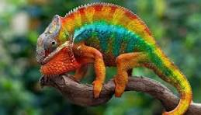 | Changes colour to hide | Camouflage
Frog | 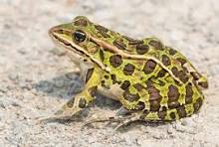 | Lives on land and in water | Moist skin and webbed feet
Birds | 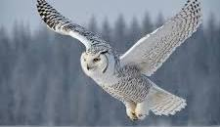 | Fly from one place to another | Streamlined body  Wings and hollow bones

(II) Roll Numbers 15-30: PROJECT — ANIMAL LIFE CYCLE FOLDOUT
Project: Create a Visual Model of Animal Life Cycles
Objective: To understand and visually represent how different animals reproduce and grow.
Instructions:

1. Choose an animal (Frog or Butterfly).
2. Collect information about its life cycle.
3. Take a long strip of white paper and fold it into 4 equal boxes like an accordion.
4. In each box, draw and label the stages of the butterfly/ frog life cycle.
5. Write one short sentence below each picture explaining the stage.
6. Colour all the pictures neatly and decorate them according to the animal.

Submission Format: Foldout of animal lifecycle. (Sample images are given below)
https://youtube.com/shorts/K8YaRTU9HR8?si=kUx9I2SwC21GJYPE
https://youtube.com/shorts/QTrxCiREQHY?si=WjqVssQmJD3BHtRf

SUBJECT: ART INTEGRATION

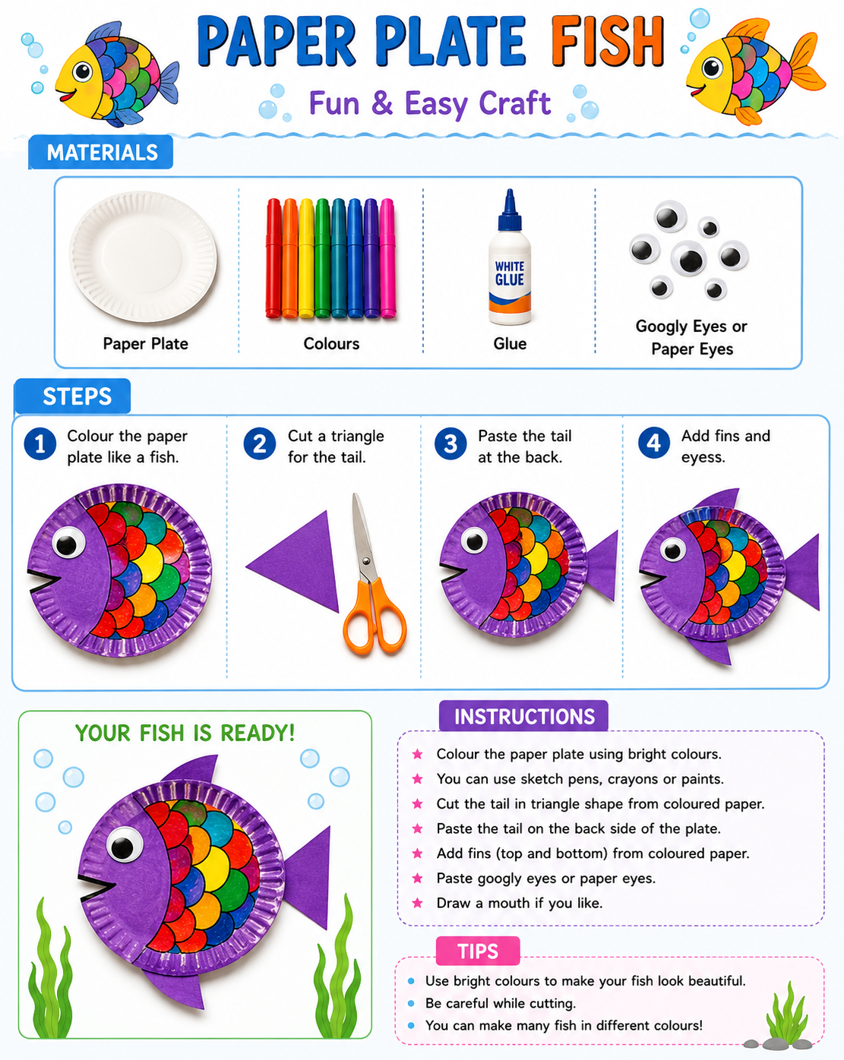

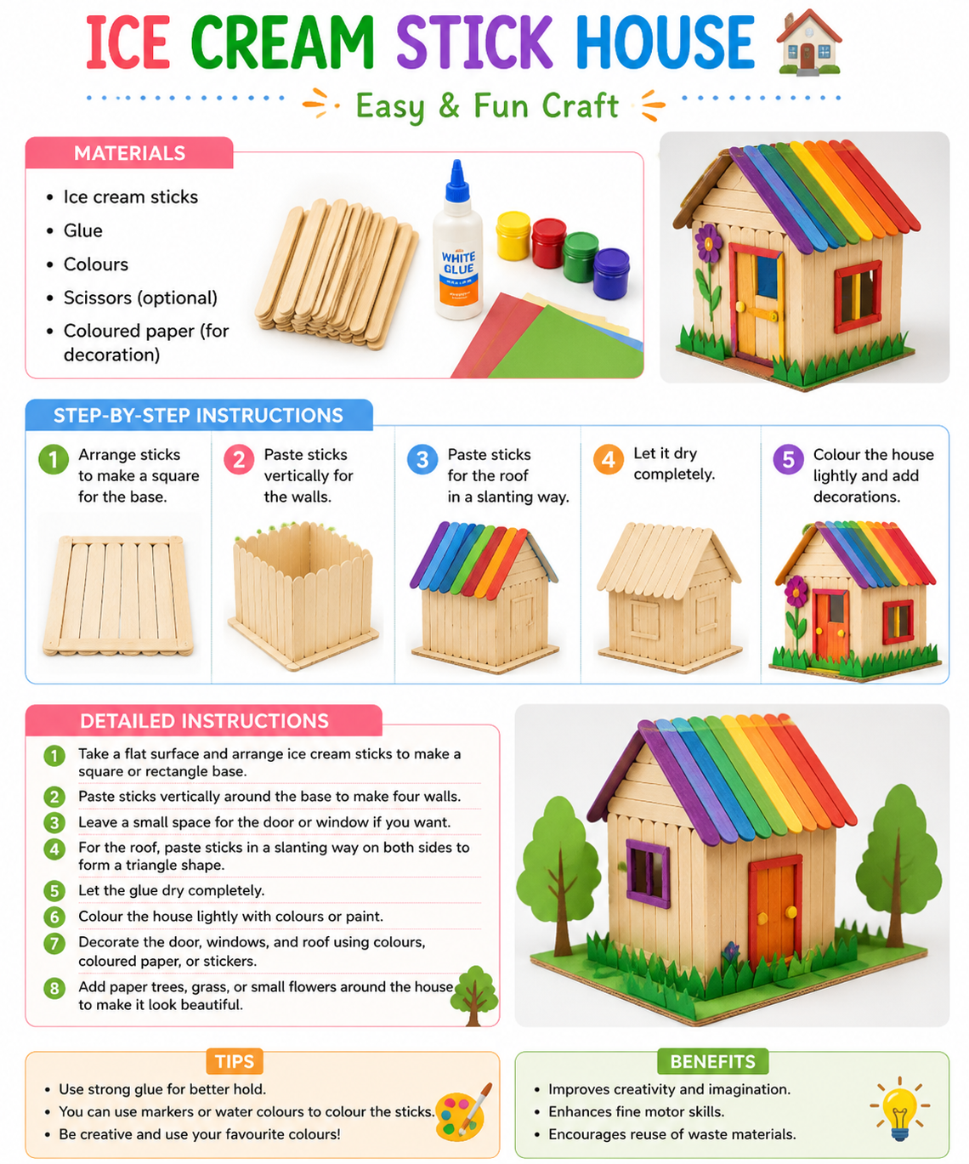

Bonus Activity
Make a paper robot using old boxes or paper cups and decorate it creatively!

Computational Thinking – Grade 4

APRIL ASSIGNMENT
Name: ____________________ Class/Sec: __________ Roll No.: __________

Chapter 1: Shapes Around Us
- What will come in place of "?" Note: You cannot rotate the images

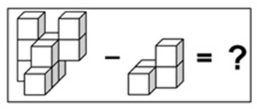
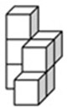
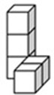
c) 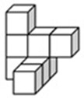 d) 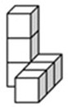
a)
b)

- The figure below forms a cube when folded. Which of the following options represents a pair of opposite faces of the cube?
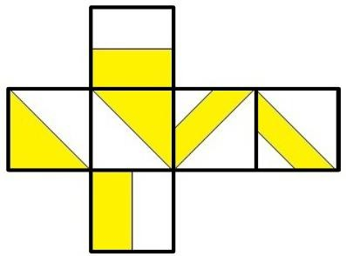
Note: You cannot rotate the question or option images
  -  b)  c)  d) 

- From a rectangular piece of paper, a shape having which of the following number of angles CANNOT be formed by making only a SINGLE STRAIGHT CUT in any direction?
  - 3 angles b) 4 angles c) 5 angles d) 6 angles

- Count the number of TRIANGLES in the image given below.

  - 4 b) 5 c) 3 d) 2

- Find the ODD one out.
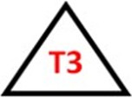
  -  b) c)  d) 

- If each of the given terms follows the same theme, what will come in place of "?"

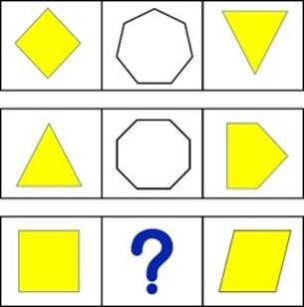


c)  d) 
a)
b)

- Each face of a triangular prism is coloured with a colour in such a way that no two adjacent faces have the same colour. What is the MINIMUM number of colours required to do this?
Note: Two faces are said to be adjacent if they share a common edge
  - 2 b) 3 c) 4 d) 5

- Which of these shapes will come in place of A and B, such that no two shapes having the same number of sides, pattern, or colour appear in the same row or column?
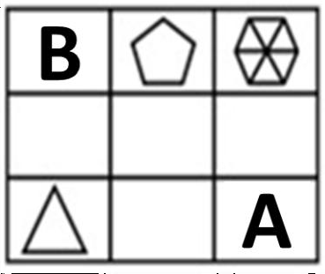
Note: Not all blocks will necessarily have a shape present in them




a) b)
c) d) 

- Six concrete blocks of cubical shape are used for building the stairs as shown below. How many faces of these blocks are not visible?

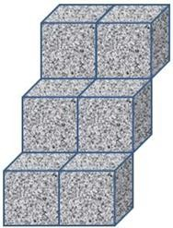
- 12 b) 15 c) 21 d) 24

- How many edges of the pyramid shown below have a yellow dot at one of their corners but do not have a red dot on the other corner?
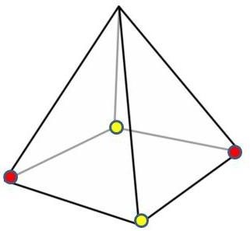
  - 1 b) 2 c) 3 d) 4

Chapter 2: Hide and Seek
- Sam travels from Start to End by visiting every block. He collects an item from every block except from the block which comes immediately after a GREY BLOCK.
What is the TOTAL NUMBER of items he will collect?
  - 4 b) 5 c) 6 d) 7

- The star must follow the arrows and return back to the square. How many different paths can it take?
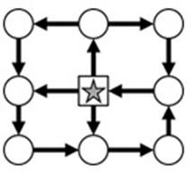
  - 4 b) 5 c) 2 d) 3

- A, B, C, and D each go to one of the following places: the Zoo, the Shop, the Cafe, and the Gym.
- Each person visits a DIFFERENT location and starts from a DIFFERENT white square
- B reaches the Gym in exactly 1 turn
- A reaches the Cafe in exactly 2 turns
- D did not take any turns to reach his destination
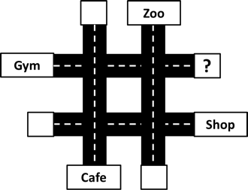
Who among them started from the square having the question mark?
  - A b) B c) C d) D

- Sam wants to reach HOME by walking along the GREY STRIP. Identify the missing part of the strip.
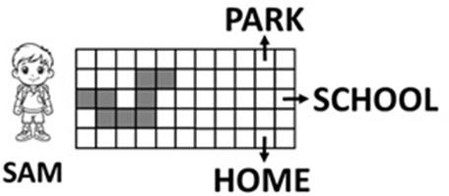

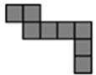
Note: You are not allowed to rotate any of the option images
a) b) 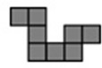 c) 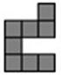 d)

- In the grid given below, which letter has the MOST number of arrows pointing towards it?
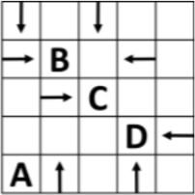
  - A b) B c) C d) D

- Which of the following options is the Top view of the question image?
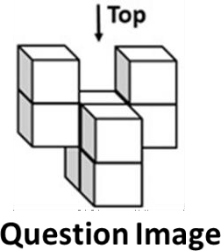
Note: You cannot rotate the question or option images
  - 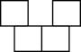 b) 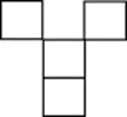 c) 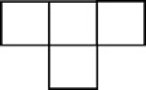 d) 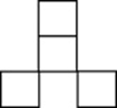

- Which of the views given in the options shows the highest number of different colours?
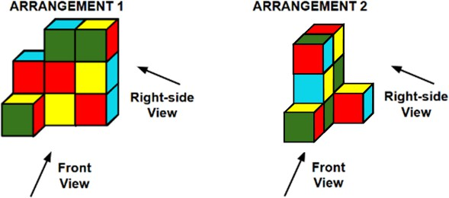
  - Front View – ARRANGEMENT 1 b) Right-side View – ARRANGEMENT 1
c) Front View – ARRANGEMENT 2 d) Right-side View – ARRANGEMENT 2

- Which of the following options will look like Figure X when viewed along the direction of the arrow? Note: You cannot rotate the question or option images

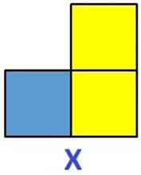


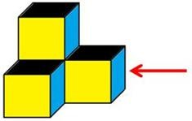

  - ​
a)
c)

d)

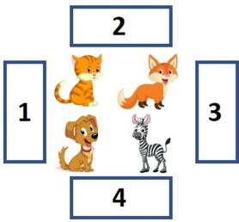
- If a person is standing on block number 3, facing the animals, what will be the position of the cat with respect to the fox from his point of view?
  - In front b) Behind c) Left d) Right

- Which of the following figures is the top view of the solid? Note: You cannot rotate the question or option images

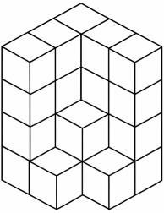

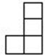
b) 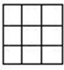 c) 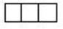 d)
a)

Values & Life Skills Assignment
1. Confidence – “I Know I Can”
Case Study
Rhea was nervous about the inter-school speech competition. She had practiced well but felt her voice would shake on stage. Her class teacher said, “Confidence doesn’t mean you’re never scared. It means you try even when you’re scared.” Rhea took a deep breath, remembered her practice, and spoke clearly. She didn’t win first prize, but the audience clapped loudly. Her teacher told her, “I’m proud of your courage.”
Tick the correct answer:
- Why was Rhea nervous?
a) She hadn’t practiced
b) She didn’t like her teacher
c) She was scared of speaking on stage
- What did the teacher teach her about confidence?
a) Avoid competitions
b) Try even when you feel scared
c) Never feel scared
- What happened after Rhea spoke?
a) People clapped and her teacher praised her
b) Everyone laughed
c) She was disqualified
- What is the main lesson?
a) Only winners are confident
b) Confidence comes without practice
c) Courage means trying despite fear
Short Answer
Write 4 sentences:
Describe a time you felt nervous but still tried. How did it feel afterward?
Activity
Write 3 positive affirmations about yourself.
Example: “I am a good learner.”
Say them out loud every morning for 3 days.
2. Respecting Elders – “Grandpa Is Wise”
Case Study
Arjun was upset because his phone was taken away for a week. He complained to his grandfather. Grandpa smiled and said,
“When I was your age, we didn’t have phones, but we had time to play outside and talk to family.”
He told Arjun stories about his childhood. By the end of the evening, Arjun realized that spending time with family was also fun. He started helping Grandpa in the garden the next day.

Tick the correct answer:
- Why was Arjun upset at first?
a) His phone was taken away
b) He lost his school bag
c) He had an exam
- What did Grandpa do to help him?
a) Gave him a new phone
b) Ignored him
c) Shared stories from his childhood
- What did Arjun learn?
a) Phones are more important than family
b) Time with family and elders is valuable
c) He should argue with parents
- How did Arjun show respect after the talk?
a) He helped Grandpa in the garden
b) He shouted at Grandpa
c) He stayed in his room
Short Answer
Write 4 sentences:
Why should we listen to elders even when we don’t agree?
Activity
Spend 15 minutes talking to an elder at home.
Ask them one question about their childhood and write one interesting thing you learned.
Request him/her to sign here _________________.

3. Empathy – “Helping Is Caring”
Case Study
During lunch break, Pihu noticed her classmate Sam was sitting alone and not eating. When she asked, Sam said, “I forgot my lunch and I’m too shy to ask.” Pihu shared half of her sandwich and sat with him. Later, Sam said, “Thank you. I felt so lonely.” Pihu smiled and said, “Friends help each other.”
Tick the correct answer:
- Why was Sam upset?
a) He lost his book
b) He forgot his lunch and felt shy
c) He had a fight
- What did Pihu do?
a) Ignored him
b) Told the teacher
c) Shared her food and sat with him

- What does empathy mean in this story?
a) Feeling angry at others
b) Competing with friends
c) Understanding and helping someone’s feelings
- How did Sam feel at the end?
a) Grateful and less lonely
b) Embarrassed
c) Angry
Short Answer
Write 4 sentences:
Describe a time you helped someone who was sad or upset.
Activity
“Kindness Challenge”
Do one small kind act this week for a classmate, sibling, or neighbour.
Write what you did and How they reacted?

Note for Parents
Discuss the case studies with children after reading. Asking “Why do you think the character acted that way?” to build reflection skills.
Students are instructed to complete the Holiday Homework neatly in their Moral Education Notebook and on the given worksheet only.



