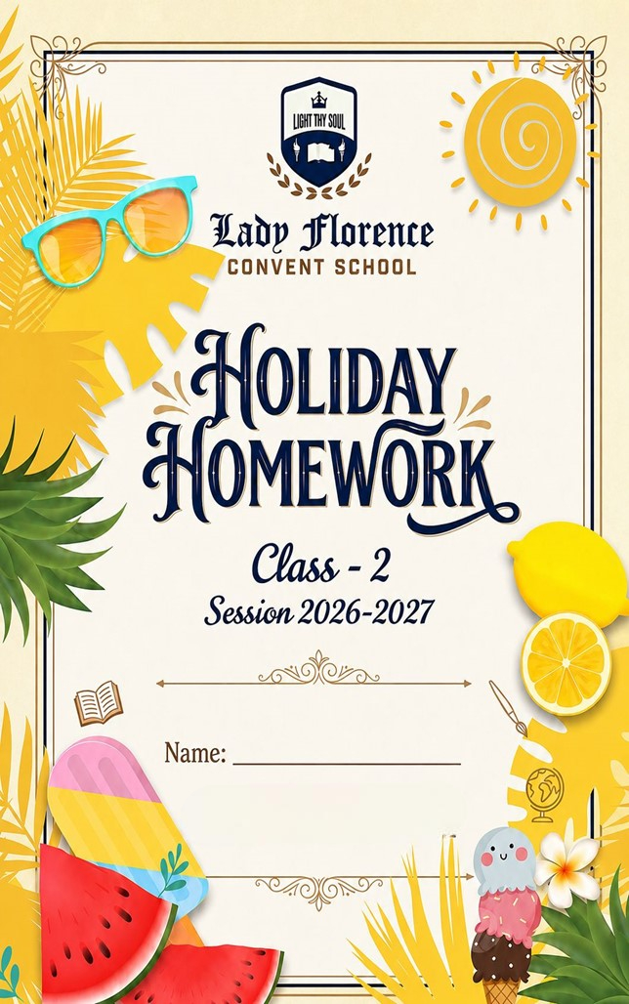

Dear Students
Summer vacation is here! ☀

It’s time to relax, refresh, and enjoy beautiful summer days with your family and friends. May your holidays be filled with happiness, laughter, fun activities, and new experiences.

Use these vacations wisely by reading storybooks, helping your parents, practicing good habits, and exploring your creativity. Don’t forget to complete your holiday homework neatly and on time.

Handwritten Content:
- Ensure all textual work is fully handwritten by the students.
- Visual Elements: Integrate relevant drawings, diagrams, or printed pictures to support findings.
- File Organization: Compile all finished assignments securely inside a clearly labeled folder.

Academic Core & Revision Syllabus
- Revision: Revise all chapters taught prior to the vacation for upcoming tests.
- Mathematical Drills: Practice core mental math worksheets and memorize numerical tables.
- Subject Integration: Complete assigned Subject Enrichment Activities (SEA) like model building or map tracing.

Submission & Evaluation
- Mandatory Status: All vacation homework assignments are compulsory academic components.
- Strict Deadlines: Submit Holiday homework timely in the organized folder.

☀ Health & Routine Guidelines
- Set a Timetable: Budget early morning hours for studying to keep afternoons entirely open.
- Beat the Heat: Avoid playing directly under midday sunshine or in extreme hot spots.
- Stay Hydrated: Drink plenty of fluids, and focus on your diet enriched with nutrient-rich seasonal fruits.
- Screen Time Limits: Restrict daily television viewing and digital gaming to less than one hour.

SUBJECT - ENGLISH
Q1. Look at the picture and write 5-6 lines with the help of given clues.
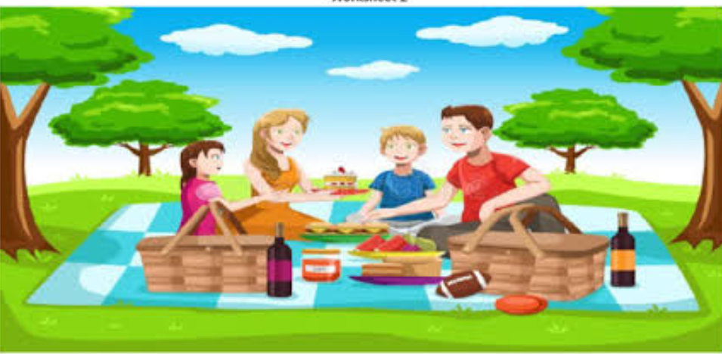
(Family, picnic, food, blanket, trees, happy, eating, sunny, enjoying, laughter)

______________________________________________________________________________

______________________________________________________________________________

_______________________________________________________________________________

_______________________________________________________________________________

_______________________________________________________________________________

_______________________________________________________________________________

Q2. Complete the story with the help of the given clues.
The Hen and the Golden Egg
Once there was a farmer. He had a ______________ (hen/cow). The hen was very special. Every day it gave a _____________ (golden/white) egg. The farmer sold the golden egg in the market. Soon he became ________________ (rich/poor). But the farmer was ______________ (greedy/happy). He wanted all the eggs at once.One day he thought, “I will cut the hen and take all the _______________ (eggs/feathers) from inside.”He cut the hen. But there were no eggs inside. The hen _________ (died/lived) and the farmer lost everything.
Moral: Do not be ______________ (greedy/kind).

Q3. Read the passage and answer the given questions.
Aman lives in a small village. Every morning, he wakes up early and goes for a walk with his grandfather. They walk near a river where many birds come to drink water. Aman enjoys watching the birds fly in the sky. His grandfather tells him the names of different birds like sparrow, parrot, and peacock.
After the walk, Aman helps his mother in the garden. He waters the plants and removes dry leaves. His mother grows vegetables like tomatoes, carrots, and spinach. Aman feels happy when he sees fresh vegetables growing in the garden.
In the evening, Aman plays with his friends. They play games like cricket and hide-and-seek. At night, Aman completes his homework and listens to bedtime stories from his grandmother. He goes to bed with a smile on his face.
A. Choose the correct answer:
i) Where does Aman live?
a) In a city b) In a village c) In a forest
ii) Who goes for a walk with Aman?
a) His father b) His grandfather c) His friend
iii) Where do they see birds?
a) Near a river b) In the market c) At school
iv) What does Aman do in the garden?
a) Plays games b) Waters plants c) Sleeps
V) Which game does Aman play?
a) Football b) Chess c) Cricket
B. Answer the following:
i) Name any two birds mentioned in the passage.
_________________________________________________________________
ii) What vegetables does Aman’s mother grow?
_________________________________________________________________
iii) Who tells Aman bedtime stories?
________________________________________________________________

C. Fill in the blanks:
i) Aman wakes up ______ in the morning.
ii) Aman goes to bed with a ______ on his face.
Q4. Circle the Proper nouns and underline the common nouns.
i) Riya is playing with a doll.
ii) The dog is barking at Amit.
iii) We went to Delhi in a car.
iv) Sita has a red bag.
v) The boy is flying a kite.
vi) Rahul lives in Mumbai.
vii) The teacher is talking to Neha.
viii) My father works in a hospital.
ix) The Ganga is a long river.
x) Ramesh is reading a book.

Q5. Fill in the blanks with a, an, or the.
i) I have ___ apple.
ii) She is reading ___ book.
iii) This is ___ umbrella.
iv) We saw ___ elephant in ___ zoo.
v) He is ___ honest boy.
vi) I have ___ pen and ___ eraser.
vii) ___ sun is very bright.
viii) She ate ___ orange.
ix) We went to ___ park.
x) Mr Sharma is ___ teacher.

Q6. Change the number (Singular → Plural):
i) boy → __________
ii) cat → __________
iii) book → __________
iv) apple → __________
v) toy → __________
B. Change the gender (Masculine → Feminine):
i) boy → __________
ii) king → __________
iii) father → __________
iv)uncle → __________
v) lion → __________

Phonics based worksheet and storytelling

The Magic 'E' (Long Vowels)
The "Silent E" at the end of a word tells the first vowel to say its name. Add an 'e' to the end of these words and write the new word.
Short Vowel Word | Add 'e' | New Long Vowel Word
Can | + e | Cane
Hop | + e | __________
Kit | + e | __________
Cub | + e | __________
Tap | + e | __________

Consonant Blends (Beginning Sounds)
Choose the correct blend from the box to complete the sentences.
[Sl / Gr / St / TR]
- The ____ass is very green today.
- Please ____and up when the bell rings.
- I saw a tiny ____ug crawl across the floor.
- Don't ____ip on the rug!

Word Detective (Diphthongs)
Words with 'ou' and 'ow' often make the same sound (like in "Cloud" or "Cow"). Fill in the missing letters for these "Ouch!" sounding words.
- I live in a big h__ __se.
- The cl__ __n made us laugh at the circus.
- Turn that fr__ __n upside down!
- Can you c__ __nt to one hundred?

Project work –
- Make a beautiful ecofriendly home using waste material.
You can use cardboard box, bottle cap, straw etc.

- Write five lines on My Self on a A3 size sheet and decorate it beautifully.
- Make a beautiful chart of Noun. per the instructions given below:

Instructions:
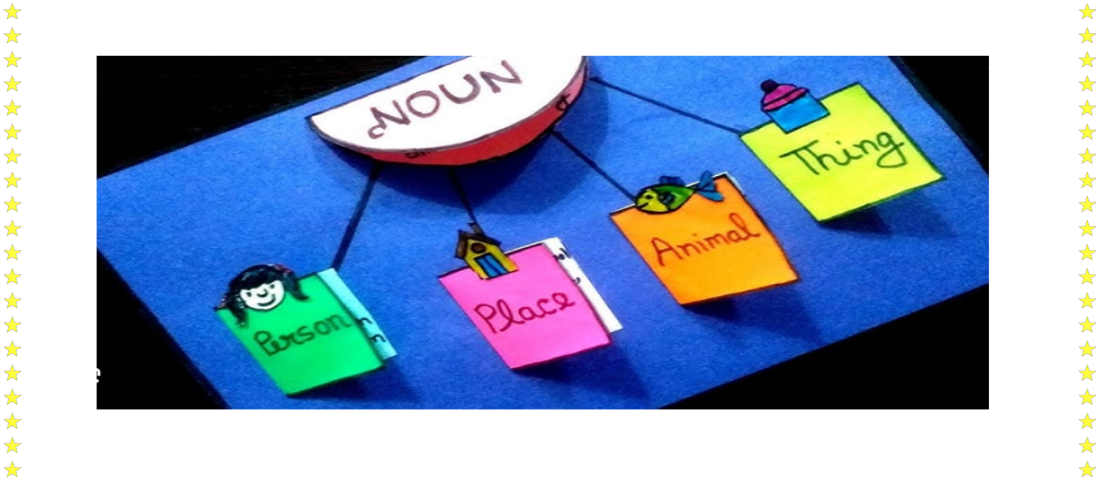
Persons in Green, Things in Yellow, Places in Pink, Animals in Orange

Note – Complete Page no 2 to 16 in cursive writing book.

SUBJECT - MATH

Q1. Write the number names:
i) 123 = ____________________
ii) 245 = ____________________
iii) 368 = ____________________
iv) 410 = ____________________
v) 579 = ____________________
vi) 682 = ____________________
vii) 731 = ____________________
viii) 804 = ____________________
ix) 956 = ____________________
x) 999 = ____________________

Q2. Draw the beads on the abacus to represent the given numbers.
i) 903 ii) 561

iii) 472 iv) 156

Q3. Write the expanded form of the given numbers.
i) 234 = ____________________
ii) 567 = ____________________
iii) 809 = ____________________
iv) 410 = ____________________
v) 725 = ____________________
vi) 990 = ____________________
vii) 302 = ____________________
viii) 684 = ____________________
ix)150 = ____________________
x) 478 = ____________________

Q4. A. Arrange the given numbers in ascending order:
i) 345, 123, 567, 234 → ____________________
ii) 890, 456, 678, 321 → ____________________
iii) 765, 432, 543, 654 → ____________________
iv) 210, 120, 201, 102 → ____________________
v) 999, 809, 980, 890 → ____________________
B. Arrange the given numbers in descending order:
i) 345, 123, 567, 234 → ____________________
ii) 890, 456, 678, 321 → ____________________
iii) 765, 432, 543, 654 → ____________________
iv) 210, 120, 201, 102 → ____________________
v) 999, 809, 980, 890 → ____________________

Q5.Write Even or Odd:
i) 12 = ________
ii) 35 = ________
iii) 48 = ________
iv) 67 = ________
v) 90 = ________
vi) 21 = ________
vii) 56 = ________
viii) 73 = ________
ix) 84 = ________
x) 99 = ________
B. Circle the even numbers:
14, 27, 36, 45, 52, 63, 70, 81
C. Circle the odd numbers:
11, 24, 35, 48, 59, 60, 73, 82
Q6. Write tables (2-10) in your Math notebook.
NUMBER GAMES

Game 1: Number Detective (Place Value)

Read the clues and write the secret number in the box.

I have 3 tens and 7 ones. What number am I? ➡️ [ __ ]

I am greater than 45 but less than 47. What number am I? ➡️ [ __ ]

I have 1 hundred, 0 tens, and 5 ones. What number am I? ➡️ [ __ ]

4. If you count by 10s, I come right after 80. What number am I? ➡️ [ __ ]

Game 2: Help Freddy Frog Jump! (Skip Counting)

Fill in the missing numbers.

Count by 2s: 22, 24, _, 28, __, 32, __

Count by 5s: 50, 55, __, 65, __, 75, __

Count by 10s: 110, 120, __, 140, __, 160

OBJECT COUNTING WORKSHEET
Array Counting (Rows and Columns)
Count the items using rows (across) and columns (down).

How many rows? ____
How many circles in each row? ___
Total circles = __ + __ + __ = ____

How many rows? ___
How many stars in each row? ___
Total stars = __ + __ + __ + __ = ___

SUBJECT: EVS
Q1. Draw a picture of the plant and label its parts.

Q2. Go for a walk in nature and use your senses to observe the environment.
Write your observations below.
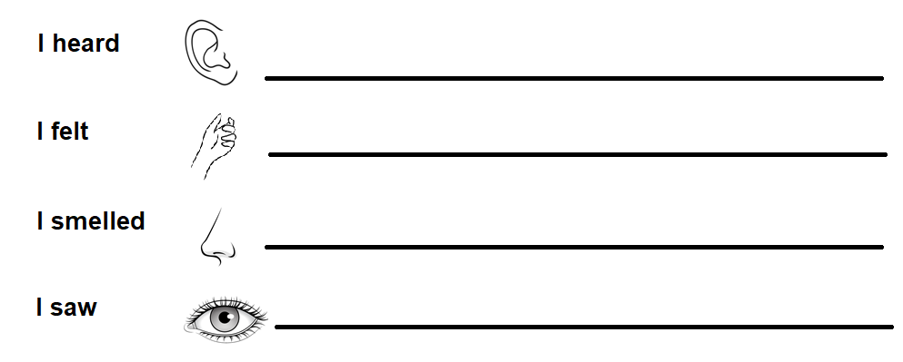

Q3. Circle the living things.
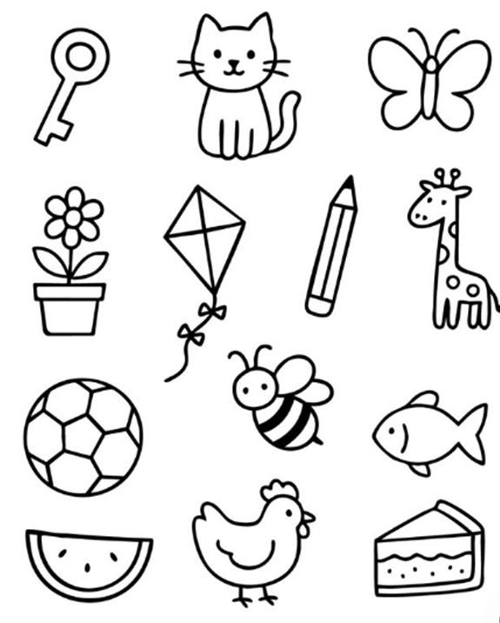
Q4. A) Tick (√) the correct answer
i) Which plant has thorns?
a. Grass b. Spinach c. Cactus
ii) Which tree has no branches?
a. Mango b. Neem c. Coconut
iii) Which of the following is a plant product?
a. Perfume b. Milk c. Wool
iv) ____ needs support to grow upwards.
a. Trees b. Climbers c. Shrubs
v) Which part of the plant makes food?
a. Fruit b. Leaves c. Root

B. Give two examples of following parts of the plants we use as food
Stem _______ _______
Root _______ _______
Leaves _______ _______
Seeds _______ _______
Flowers _______ _______
C. Match the following
Column A Column B
1. Cauliflower seed
2. Green Peas stem
3. Sugarcane flower
4. Carrot leaf
5. Spinach fruit
6. Mango root
Q5. Make a poster on “Environment day” (A3 size sheet).

Q6. Draw two pictures of fruits, which we eat in summer season.

Subject Enrichment Activity

Cut and Paste Sorting
Cut pictures from old magazines or newspapers and paste them into the correct column.
W Cow , Goat ,Tiger, Crow, Deer ,Wolf , Human , Lion
Bear

He Herbivores | Ca Carnivores | O Omnivores

SUBJECT - ART AND CRAFT

Q1. Color an aeroplane as per the given instructions.
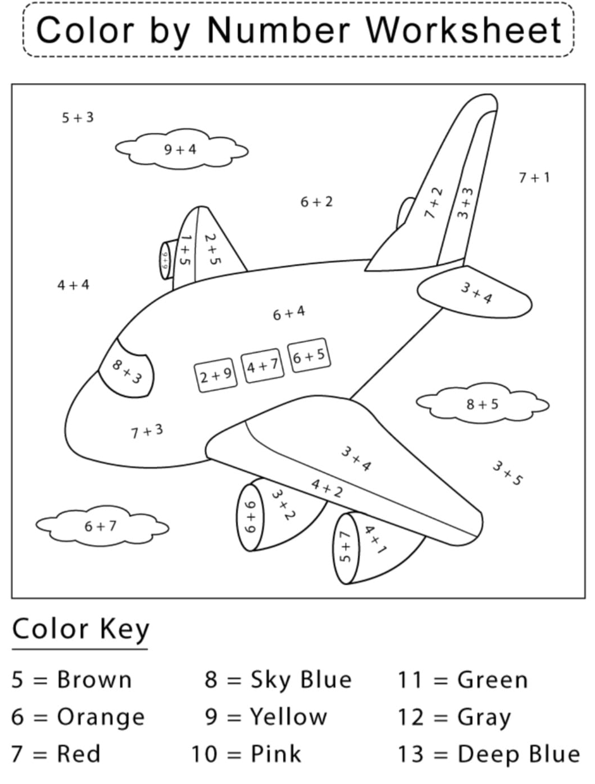

Q2. Add the numbers and color the picture as per the given instructions.

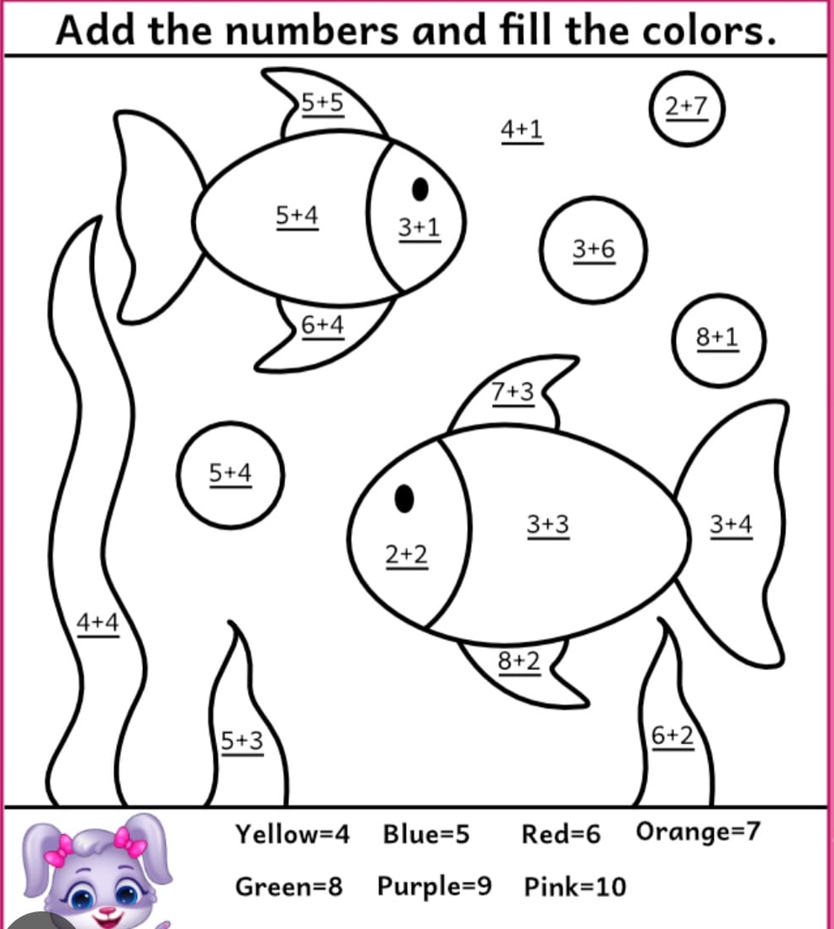

Q3. Fill the color in the given picture:

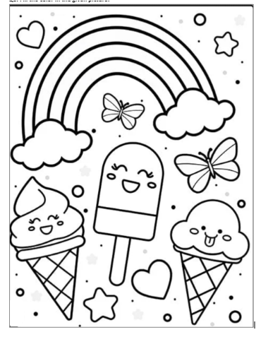

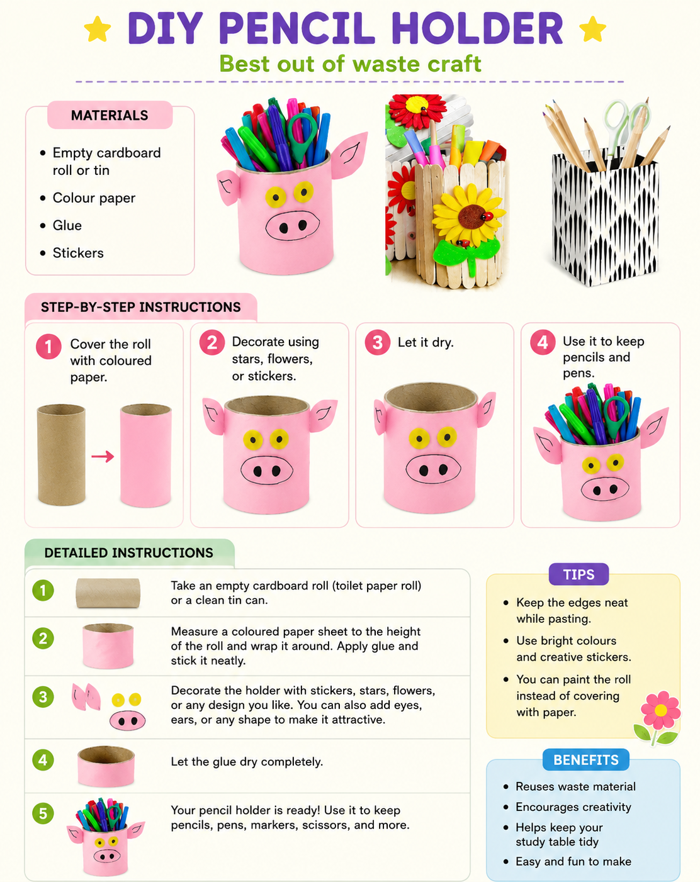
विषय- हिंदी
प्रश्न 1. निम्नलिखित गद्यांश को पढ़ कर निम्नलिखित प्रश्नों के उत्तर दीजिए I

सीमा अपने परिवार के साथ एक छोटे गाँव में रहती थी। गाँव के पास एक सुंदर नदी बहती थी। गर्मियों की छुट्टियों में सीमा रोज सुबह अपने दादाजी के साथ नदी किनारे घूमने जाती थी। वहाँ वह रंग-बिरंगे पक्षियों को देखती और पेड़ों की ठंडी छाया में बैठकर कहानियाँ सुनती थी। दादाजी उसे प्रकृति की रक्षा करने की सीख देते थे। सीमा ने निश्चय किया कि वह कभी पेड़ नहीं काटेगी और अपने आसपास सफाई रखेगी।

प्रश्न 1. सीमा कहाँ रहती थी?

प्रश्न 2. गाँव के पास क्या बहता था?

प्रश्न 3. सीमा किसके साथ घूमने जाती थी?

प्रश्न 4. दादाजी सीमा को क्या सीख देते थे?

प्रश्न 5. सीमा ने क्या निश्चय किया?

प्रश्न 2. निम्नलिखित वाक्यों में संज्ञा शब्दों पर गोला लगाओ I

- राधा बगीचे में खेल रही है।
- मोहन के पास नई किताब है।
- बिल्ली दूध पी रही है।
- सूरज आकाश में चमक रहा है।
- बच्चे पार्क में दौड़ रहे हैं।पिताजी अखबार पढ़ रहे है ।
- राधिका बाज़ार जा रही है ।
- शेर , चीता , हिरण , भालू सारे जानवर जंगल मे रहते है ।

प्रश्न 3. अक्षरों को जोड़कर शब्द बनाओ:
क + म + ल = __________
प + त + ं + ग = __________
ब + क + र + ी = __________
म + छ + ल + ी = __________

प्रश्न 4 .निम्नलिखित शब्दों के वचन बदलो ।
- तारा _____________________________
- गमला _____________________________
- बेटा _____________________________
- भाई _____________________________
- राजा _____________________________
- शेर _____________________________
- पिता _____________________________
- बकरा _____________________________
- मोर _____________________________
- दादा _____________________________
प्रश्न 5. निम्नलिखित शब्दों के समान तुकवाले शब्द लिखो ।
- बात _____________________________
- मन _____________________________
- ताला _____________________________
- पवन _____________________________
- पाक _____________________________
- कण _____________________________
- नगर _____________________________
- कब _____________________________
प्रश्न 6. निम्नलिखित शब्दों के अर्थ लिखो ।
- तनिक _____________________________
- अभिलाषा _____________________________
- साहस _____________________________
- पूर्ण _____________________________
- न्योछावर _____________________________
प्रश्न 7. निम्नलिखित प्रश्नों के उत्तर लिखो ।
प्रश्न1. भारत के बच्चों में कौन से गुण है?
____________________________________________________________
प्रश्न2. बच्चे किन्हें सबक सिखाना चाहते हैं?
______________________________________________________________

प्रश्न3. बच्चे शरीर के दुबले होने पर भी कैसे हैं?
______________________________________________________________

प्रश्न 8 ‘मेरा प्यारा देश’ विषय पर पाँच पंक्तियाँ लिखो I
1
2
3
4
5

प्रश्न 9 चित्र को देखकर पाँच पंक्तियाँ लिखो I
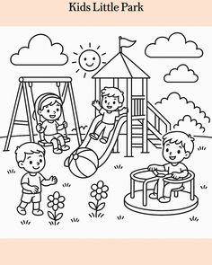

1
2
3
4
5

गतिविधि
- अपने भारत देश पर एक कविता लिखें ए-4 शीट पर लिखे I
- अपने देश को आगे बढ़ाने के लिए क्या- क्या करना चाहिए? A-4 शीट पर लिखें I
- सुलेख अभ्यास – सुलेख पुस्तक में पृष्ठ 1-15 तक करे I

SUBJECT - Values & Life Skills Assignment

Respecting God – “Thank You God”

Case Study:
It was a hot afternoon and the electricity went out. Aarav started feeling upset because he couldn’t watch cartoons. His grandmother said, “Let’s sit outside and thank God for the breeze, the trees, and the water we have.” Aarav closed his eyes and said a small prayer. After that, he felt calm and happy, even without the fan.

Tick the correct answer:
  - Why did Aarav feel upset at first?
    - The electricity went out
    - He had no food
    - He fought with his sister
  - What did Grandmother suggest to help him feel better?
    - Play a game
    - Thank God for small blessings
    - Sleep
  - What does this story teach us?
    - We should complain when things go wrong
    - God only helps when electricity is on
    - We should be thankful even for small things

Activity: My Gratitude List
Write 3 things you thank God for:
i.
ii.
iii.

Politeness and Respect – “Good Morning Teacher!”

Case Study:
Riya entered school late. She quietly went to her teacher and said, “Good morning, ma’am. I am sorry I am late.” The teacher smiled and said, “Thank you for telling me politely. Next time, try to come on time.” Riya
felt respected and promised to be punctual.

Tick the correct answer:
  - How did Riya greet her teacher?
    - She shouted from the door
    - She did not greet her
    - She said “Good morning” politely and apologized

  - Why did the teacher appreciate Riya?
    - Because she was late
    - Because she spoke politely and admitted her mistake
    - Because she gave a gift
  - What is the right way to show respect to elders?
    - Ignoring them
    - Copying their work
    - Speaking politely and listening to them

Activity: Respect Role Play
- Write 2 polite sentences you can use with your teacher and parents.
  - With teacher:
  - With parent:
- Act out one situation at home where you greet an elder politely. Request the person to sign here:

Admitting Mistakes – “I Broke The Pot”

Case Study:
While playing indoors, Karan accidentally knocked over a flower pot. He was scared his mother would scold him. But he remembered his teacher’s words: “Honesty makes you strong” Karan went to his mother and said, “Mum, I broke the pot by mistake. I am sorry.” His mother said, “I am proud you told the truth. We will clean it together.”

Tick the correct answer:
  - What did Karan do after breaking the pot?
    - Hid it under the bed
    - Blamed his brother
    - Told his mother the truth and apologized
  - Why did Karan feel brave to speak the truth?
    - His mother was not at home
    - He remembered that honesty makes you strong
    - He didn’t care
  - What did Karan learn from this experience?
    - Playing indoors is fun
    - Pots are not important
    - Admitting mistakes builds trust

Note for Parents:
Encourage children to answer in their own words. Focus on understanding the value behind each story.


NOTE: Holiday homework should be submitted on the first day after school reopens.

