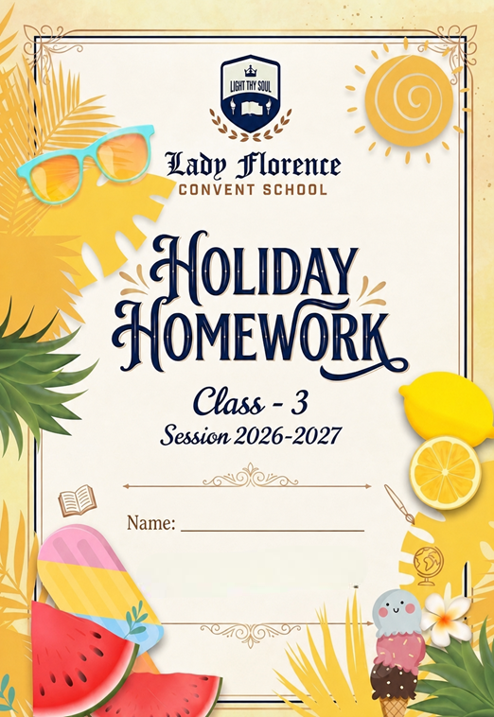
Dear Students
Summer vacation is here! ☀

It’s time to relax, refresh, and enjoy beautiful summer days with your family and friends. May your holidays be filled with happiness, laughter, fun activities, and new experiences.
Use these vacations wisely by reading storybooks, helping your parents, practicing good habits, and exploring your creativity. Don’t forget to complete your holiday homework neatly and on time.

Handwritten Content:
- Ensure all textual work in fully handwritten by the students.
- Visual Elements: Integrate relevant drawings, diagrams, or printed pictures to support findings.
- File Organization: Compile all finished assignments securely inside a clearly labeled folder.

Academic Core & Revision Syllabus
- Revision: Revise all chapters taught prior to the vacation for upcoming tests.
- Mathematical Drills: Practice core mental math worksheets and memorize numerical tables.
- Subject Integration: Complete assigned Subject Enrichment Activities (SEA) like model building or map tracing.

Submission & Evaluation
- Mandatory Status: All vacation homework assignments are compulsory academic components.
- Strict Deadlines: Submit Holiday homework timely in the organized folder.

☀ Health & Routine Guidelines
- Set a Timetable: Budget early morning hours for studying to keep afternoons entirely open.
- Beat the Heat: Avoid playing directly under midday sunshine or in extreme hot spots.
- Stay Hydrated: Drink plenty of fluids, and focus on your diet enriched with nutrient-rich seasonal fruits.
- Screen Time Limits: Restrict daily television viewing and digital gaming to less than one hour.

ACTIVITY TIME

YOGA DAY (21st June, Sunday )

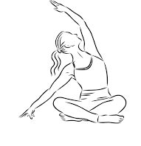
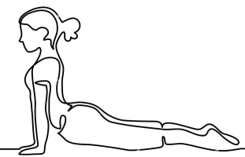
Yoga and Breathing Activity
Learn simple breathing exercises:
- Deep breathing
- Balloon breathing
- Anulom Vilom (basic level)
Homework:
Practice yoga for 5 minutes daily, make a star chart and colour a star each day of your practice and paste the pictures in scrap file.
FATHER’S DAY (21st June, Sunday )
Father’s Day Tie Craft
Using colour paper, students will make a tie and write sweet message on it such as:
“I love you Papa”
“Thank you for everything”

Reference images are given below.
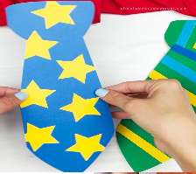
SUBJECT - ENGLISH
WORKSHEET 1
Q1: Read the passage carefully and answer the given questions.
The Helpful Tree
There was a big mango tree near Riya’s house. Many birds lived on its branches. The tree gave cool shade to people during summer. One day, Riya saw a little bird fall from the nest. The bird was hurt and could not fly. Riya carefully picked up the bird and kept it in a small basket. She gave it water and grains to eat. After a few days, the bird became healthy again. It flew back to its nest happily. Riya’s grandmother smiled and said, “Kindness always makes the world better.”
- What kind of tree was near Riya’s house?
Ans: _________________________________________________________
- Why did people like the tree?
Ans: _________________________________________________________
- What happened to the little bird?
Ans: _________________________________________________________
- How did Riya help the bird?
Ans: _________________________________________________________
- What did Riya’s grandmother say?
Ans: _________________________________________________________

Q2: Write five lines on My Father.
- ________________________________________________________________
- _________________________________________________________________
- _________________________________________________________________
- _________________________________________________________________
- _________________________________________________________________
Q3: Write five lines on the given picture.
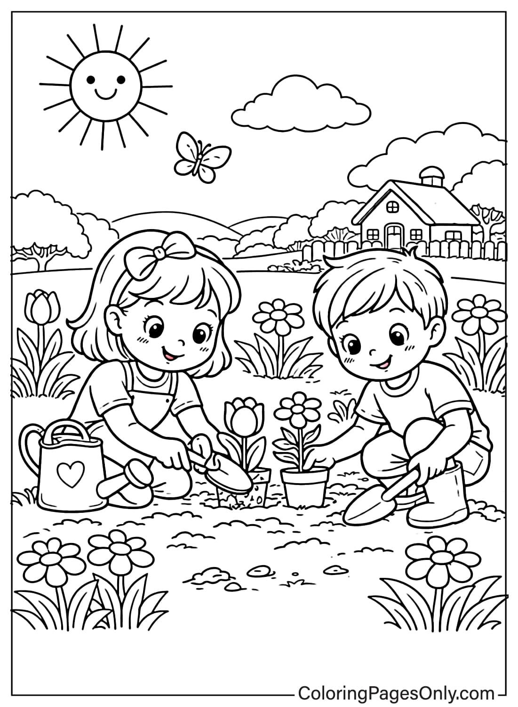
- ________________________________________________________________
- _________________________________________________________________
- _________________________________________________________________
- _________________________________________________________________
- _________________________________________________________________
WORKSHEET 2
Let’s do fun with Grammar
Q1. Fill in the blanks with a, an, or the.
- I saw ______________ elephant in the zoo.
- She bought ____________ apple from the market.
- We stayed at ________________ hotel near the beach.
- There is __________________ book on the table.
- ________________ sun rises in the east.
- ________________egg takes three days to hatch.
- John wanted to read ________________ comic book
- He found __________________ orange in the basket.
- I quickly ate ________________ cookies.
- It’s ________________ honour for me to meet you.
Q2. Underline the common noun with green colour and circle the proper noun with blue colour in the sentences given below.
1. Misha is playing with a dog.
2. This is a picture of Jawaharlal Nehru.
3. Anansi was a trickster.
4. The pilot was flying to New York.
5. Tim is playing on the computer.
6. River Ganges is in India.
7. Siya is my best friend.
8. We went to Kashmir for vacation.
9. Sana lives in Mumbai.
10. I went to Pizza Hut last Saturday.

Q3. Rearrange the words given below in alphabetical order. Look at the first letter first!
1. eagle, parrot, sparrow, owl, duck
2. mango, grape, pineapple, lemon, kiwi
3. desk, chair, board, clock, window
4. tiger, zebra, lion, bear, wolf
5. mars, earth, venus, jupiter, saturn
6. butterfly, ant, beetle, wasp, ladybug
7. carrot, potato, onion, beans, spinach
Activity time
Story Review
Q1. Read any interesting English story of your choice during the summer vacations (e.g. Panchatantra, Aesop’s fables, Akbar-Birbal) and prepare a creative story review portfolio on an A-4 size sheet. Your review must include the following details:
- Title of the story: __________
- Author’s name/ Book name: ____________
- Main characters: ___________
- Problem: _____________
- Solution: ___________
- Moral of the story: ______________
- Star rating: Draw 5 stars at the bottom and colour them to show how much you enjoyed the book.
Vocabulary Puzzle
Q2. The letters given below are completely mixed up! Unscramble the letters to find out the correct word (hint: Use the clues to match them)
Mixed Letters | Correct Word | Hints
1. oobks |  | you open and read them.
2. oinl |  | the king of the jungle in many fables.
3. eret |  | a bird or monkey sits on this.
4. omrla |  | the good lesson at the end of the story.
5. ordw |  | letters put together make a ______.
6. ikng |  | a royal ruler who lives in castle.
7. soume |  | a tiny animal that saves the big lion.
8. lepanhte |  | animal with a trunk.
9. abnowri |  | seven coloured appears like an arc
10. irlecc |  | round in shape

Creative Writing
Q3. If a magical genie grants you only one wish for today what will you ask for and why? Use your imagination and write a short story or paragraph (4 – 5 sentences).
Ans. _____________________________________________________________________________________________________________________________________________________________________________________________________________________________________________________________________________________________________________________________________________________________________________________________________________________________________________________________________________________________________________________________________________________________________________________________________________________________________________________________________________________________________________________________________________________________________________________________
Note – Complete Page no 2 to 16 in cursive writing book.

विषय – हिंदी
प्रश्न – 1 दिए गए गद्यांश को पढ़कर पूछे गए प्रश्नों के उत्तर लिखो ।
एक दिन नेहा अपनी माँ के साथ पुस्तक मेले में गई। वहाँ अलग-अलग विषयों की बहुत-सी किताबें रखी थीं। कुछ किताबों में रंगीन चित्र थे और कुछ में रोचक कहानियाँ। नेहा को जानवरों से संबंधित पुस्तक बहुत पसंद आई। उसने देखा कि छोटे-छोटे बच्चे चुपचाप बैठकर किताबें पढ़ रहे थे। मेले में एक लेखक भी आए थे, जो बच्चों को कहानी सुना रहे थे। नेहा ने एक कहानी की पुस्तक खरीदी और निश्चय किया कि वह रोज़ थोड़ा समय पढ़ने में लगाएगी। घर पहुँचकर उसने अपनी छोटी बहन को भी वह कहानी सुनाई।

i. नेहा किसके साथ पुस्तक मेले में गई?
______________________________________________________________________
- मेले में कैसी-कैसी किताबें थीं?
______________________________________________________________________
- नेहा को कौन-सी पुस्तक पसंद आई?
______________________________________________________________________
- लेखक बच्चों को क्या सुना रहे थे?

_____________________________________________________________________
- नेहा ने क्या निश्चय किया?

_____________________________________________________________________

प्रश्न 2: निम्नलिखित वाक्यों में उचित विशेषण शब्द भरो ।
- आम बहुत ____________________ है।
- मोहित बहुत _______________ दौड़ता है।
- हिमालय बहुत _______________ पर्वत है।
- आज पानी बहुत _______________ है।
- बगीचे में __________________ फूल खिले हैं।
- माँ ने _________________ खाना बनाया है ।
- राधिका के पास ____________ गुड़िया है ।
- आसमान में ______________ बादल छाए हैं।
प्रश्न 3: नीचे दिए गए वाक्य में पुल्लिंग शब्दों को स्त्रीलिंग में बदलकर लिखिए।

- धोबी कपड़े धोता है ।
→ _______________________________________________________
- अध्यापक कक्षा में पढ़ा रहा है ।
→ _______________________________________________________
- नौकर काम कर रहा है ।
→ _____________________________________________________
- माली बगीचे में काम कर रहा है ।
→ _____________________________________________________

v. पिताजी बाज़ार से फल खरीद कर लाए ।
→ ______________________________________________________

प्रश्न 4 चित्र को देखकर पाँच पंक्तियाँ लिखो ।
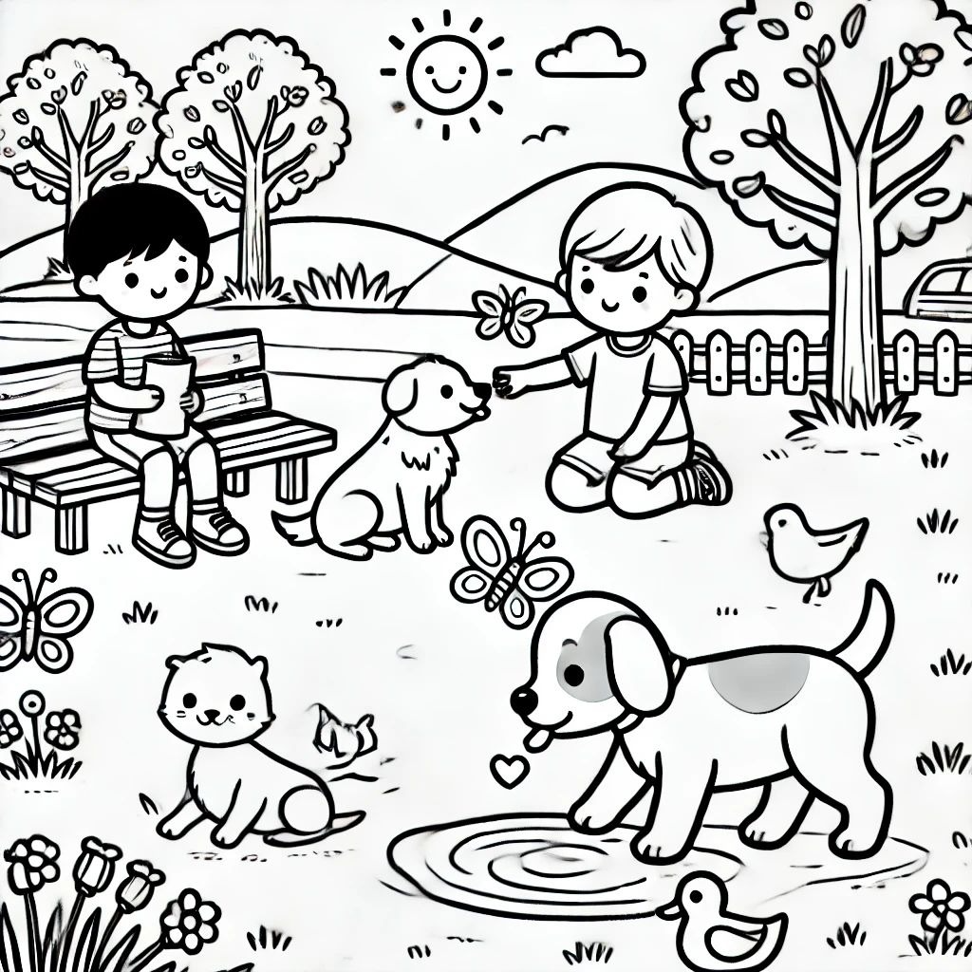

1
2
3
4
5
6

- सुलेख अभ्यास – सुलेख पुस्तक में पृष्ठ 1-15 तक करे I

SUBJECT - MATHS
WORKSHEET-1

Q1: Fill in the blanks.

i. 120 − 1 = _____ ii. 61 − ____ = 61 iii. 55 − ____ = 55
iv. ___ – 15 = 5 v. 541 ˗˗ 0 = ____ vi. 99 − ____ = 98
Q2: Subtract the following number.
i. 356 − 122 ii. 552 – 326

Q3: Subtraction without regrouping.
i. H T O ii. H T O iii. H T O
5 7 9 9 9 8 7 2 6
− 3 6 4 − 6 3 5 − 3 3 3

Q4: Subtraction with regrouping.
i. Th H T O ii. Th H T O iii. TH H T O
1 2 3 4 3 4 8 3 7 6 3 5
− 5 6 7 − 2 2 1 9 − 6 2 4 3

Q5: Word problems.
i. A library had 550 books. After some books were borrowed, only 197 remained. How many books
were borrowed?

ii. A farmer harvested 2,340 apples. He sold 1,125 apples in the market. How many apples are left?

iii. A water tank contained 4,500 litres of water. 1,950 litres were used. How much water left in the tank.

WORHSHEET – 2

Logical Reasoning
      - Circle the odd one out:
Circle, square, triangle, banana
      - Complete the pattern:
A, C, E, G,______
      - Circle the number which number does not belong in this series ?
2, 4, 6, 9, 10
      - What comes next?
1, 4, 9, 16, ____
      - If one week has 7 days, how many days are there in 5 weeks?
_____________
      - Circle the odd one out.

      - Which letter is the 10th letter of the alphabet?
____________
      - If CAT = 24, then BAT = ?
B = 2, A=1, T = 20
      - How many wheels are there in 8 bicycles?
___________________________________
      - Who has hands but cannot clap?
___________________________________

Assertion (A):
845 − 325 = 520
Reason (R):
When we subtract 325 from 845, we get 520
_________________________________________________________________________
_________________________________________________________________________
Assertion (A):
Subtraction means taking away one number from another number.
Reason (R):
In subtraction, the answer is called the sum.
_________________________________________________________________________
__________________________________________________________________________
Project work of Maths

- Fun extension activity
Roll and Subtract Game
- Materials: Dice and notebook
- Steps:
- Roll 3 dice to make a 3-digit number.
- Roll again to make another number.
- Subtract the smaller number from the bigger number.
- Repeat 5 times.
- Example:
- 542 − 318 = 224.
Measurement at home activity

Activity 1: The Bedroom Safari (Length)Goal: Measure lengths using non-standard and standard units.
- Task: Pick 5 objects in your bedroom (e.g., bed, pillow, toy box, book).
- Step 1: Estimate how many "handspans" long each object is and write it down.
- Step 2: Measure the actual length using your handspan.
- Step 3: Use a plastic school ruler to measure them in centimeters (cm).
- Output: Create a 4-column table: Object Name, Estimated Handspans, Actual Handspans, Length in cm.
- Do this activity on A-3 size sheet.

SUBJECT - EVS
WORKSHEET
Q1. Fill in the blanks
- Baisakhi is celebrated in the month of _________________________.
- We celebrate ________________________ for seven days .
- Pohela Baishakh is celebrated in __________________________.
- Vishu is celebrated on ________________________.
- Cheti Chand signifies the birth anniversary of __________________________.
- The Punjabi New Year is celebrated as ____________________________.
- _________________________ teach us to appreciate the diversity and beauty of India .
- Spring harvest festivals bring _______________ and _______________ to our lives.
- Puthandu is celebrated in the first month of ________________ calendar .
- ______________________ meal is prepared on Vishu .
Q2. Write T for true statement and F for false statements
- All festivals are celebrated in the same way in our country. ___________________
- Varun Deva is the God of earth . ___________________
- We celebrate Pohela Boishakh in August . _____________________
- We make prepare dish like sarson ka saag and make di roti on Vishu ________________.
- Bohag Bihu is celebrated as The Assamese New Year . _______________
Q3 . Match the following
- Bohag Bihu Tamil New Year
- Vishu Bengali New Year
- Cheti Chand Sindhi New Year
- Pohela Boishakh Punjabi New Year
- Baisakhi Malayali New Year
- Puthandu Assamese New Year
Q4. Answer the following questions
- Which special dishes are prepared during the spring festival you celebrate?
___________________________________________________________________________________________________________________________________________________________________________________________________________________________________________________________

- Which crops are harvested during spring in your town or village?
___________________________________________________________________________________________________________________________________________________________________________________________________________________________________________________
- Make a list of festivals celebrated in your family during the whole year.
__________________________________________________________________________________________________________________________________________________________________________________________________________________________________________________
- Which season do you like the most and why ?
_____________________________________________________________________________________________________________________________________________________________________________________________________________________________________________________

Passage Based Questions

"Children from different Indian states wearing traditional clothes and celebrating different festivals together. One child flying a kite (Baisakhi), one looking at Vishu Kani arrangement, one dancing Bihu, and one greeting with 'Shubho Nabo Barsho'. Bright festive background."
Answer the following questions .
- What are the children celebrating in the picture?
________________________________________________________________________________________________________________________________________________
- What do you notice about their clothes?
________________________________________________________________________________________________________________________________________________
- What value is shown when people celebrate different festivals together?
________________________________________________________________________________________________________________________________________________
- Which festival do you celebrate with your family?
________________________________________________________________________________________________________________________________________________

PROJECT WORK OF EVS
Project-1
Activity: “My Spring Festival Scrapbook”
Activity: Students will make a small scrapbook on Spring Festivals celebrated as New Year in different parts of India.
Festivals to Include:Baisakhi, Vishu, Cheti Chand, Pohela Boishakh, Puthandu, Bohag Bihu

Instructions:
- Take 4 -6 sheets and dedicate one page to each festival.
- Draw or paste pictures related to the festival.
- Write: Festival name
- State where it is celebrated
- Special food
- Traditional dress
- One interesting fact
Decorate each page with flowers, kites, diyas, or rangoli designs.
Creative Twist:
Students can also paste small fabric pieces, leaves, or handmade paper flowers to make the scrapbook attractive.
Learning Outcome:
Students will learn about different spring festivals celebrated as New Year in India and improve their creativity, research, and presentation skills.
Project -2
Growing Bean Seed Experiment 🌱
Materials Required
- 1 transparent glass or jar
- Cotton
- Bean seeds (rajma/chana/moong)
- Water
Procedure
- Put some cotton inside the glass or jar.
- Place the bean seeds between the cotton and the side of the glass so they are visible.
- Sprinkle a little water on the cotton.
- Keep the jar near sunlight.
- Add a little water daily to keep the cotton wet.
- Observe the changes for a few days.
Observation
The seed slowly swells, sprouts, and grows into a small plant.
Conclusion
Seeds need water, air, and sunlight to grow into plants.

SUBJECT - ART AND CRAFT ACTIVITY
Poster 1: The Magical Math Land (Scenery Drawing)
The Concept: A beautiful nature landscape where elements of scenery are made from mathematical elements.
What to Draw:
Mountains: Draw large, sharp Triangles for mountains. Give them snowy peaks using smaller white triangles.
Sun: A bright, happy Circle with rays made of alternating long and short straight lines.
Trees: Draw Cylinder trunks with Oval treetops. Alternatively, draw pine trees using overlapping triangles.
River: A winding blue river made of wavy parallel lines flowing down from the mountains.
Coloring Tip: Use dark green for the triangle mountains, light green for the oval trees, and bright yellow for the circle sun.
Make this poster on A-3 size sheet .

Computational Thinking
Worksheet -1
- Find the largest number name that is hidden in the series given below.
Note: The letters in the number name should appear together as continuous letters
  - 60 b) 6 c) 20 d) 70

- Roy’s favourite number has:
- 3 letters in its name
- The number of vowels is double the number of consonants in its name What is Roy’s favourite number?
  - 2 b) 6 c) 10 d) 1

- If each of the given boxes follows the same theme, what will come in place of “?”
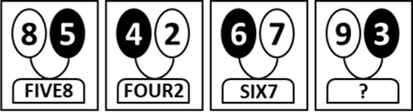
  - NINE3 b) THREE9 c) THREE3 d) 9THREE

- If each of the following terms follows the same theme, what will come in place of "?"
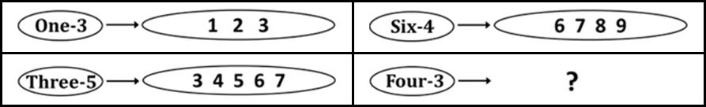
  -  b) 
c)  d) 

- If each of the following terms follows the same theme, what will come in place of “?”

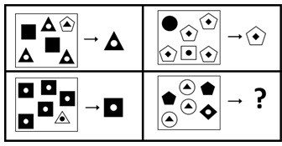


c)  d) 
b)
a)


6. Find the odd one out.
  -  b)
c)  d) 

- Which of the following number names given in the options will come second if arranged in dictionary order of their names?
  - 5 b) 6 c) 8 d) 9

- Each shape has a letter in it. Spelling (or Name) of which of the following numbers, given in the options can be formed by combining the letters in the circles only?
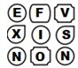
  - 1 b) 5 c) 9 d) 6

- Spelling of which of the following numbers given in the options is present in the group of letters given below?
Note: The letters of the name should appear in the same order as in the word

TWLVETOWELEVENSVENTHREEIFEIHGT
  - 2 b) 7 c) 3 d) 8

- Which of the following numbers CANNOT be spelt using the letters present in the image given below?
Note: If a letter appears in the image, it can be repeatedly used any number of times to spell the number name

  - 50 b) 30 c) 85 d) 11

Worksheet -2

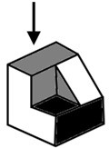
- Which of the following options represents the top view of the object given below?
  -  b)  c)  d) 

- Count the number of surfaces (faces) in the given solid.

  - 6 b) 7 c) 8 d) 9

- The given shapes are to be placed in the buckets. Shapes with a number of edges greater than 5 are kept in a yellow bucket while the others are kept in the white bucket. Out of the shapes in the yellow bucket, how many have EXACTLY 6 edges?
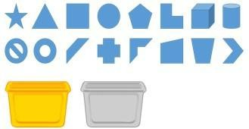
  - 2 b) 3 c) 4 d) 5

- Given below is a large box consisting of four smaller transparent boxes with some sides coloured. Which of the boxes shown in the options is not a part of the larger box in the question image?
Note: Rotation of option images is not allowed
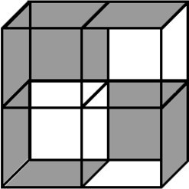
  - 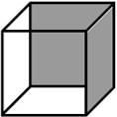 b) 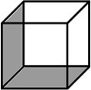 c) 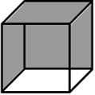 d) 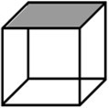

- If there is a dot on each corner of the cubes below, then how many dots are hidden?
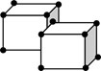
  - 3 b) 4 c) 5 d) 6

- What will come in place of 'A' and 'B'?

  -  b) 
c)  d) 

- Find the odd one out.
  - 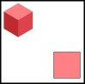 b)  c) 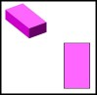 d) 

- If the given solid is viewed from the direction of the arrow, what will it look like?
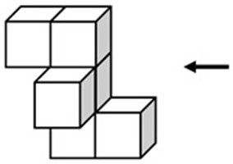
Note: You cannot rotate the question or option images
  -  b)  c)  d) 

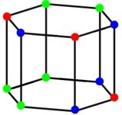
- How many edges of the solid shown below have the same-coloured dots on both of their corners?
  - 2 b) 3 c) 4 d) 5

- Which of the following options can be formed by combining the shapes given below?
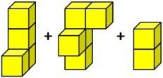

  -  b)  c)  d) 

VALUES & LIFE SKILLS ASSIGNMENT

Trusting God – “God Is There Always”

Case Study:
Rohan’s family was moving to a new city. He felt scared about making new friends and missing his old school. That night, his father read a story about David and Goliath. He said, “Rohan, when we trust God, we get courage to face new things.” The next day, Rohan prayed and felt calm. At his new school, he smiled at a classmate and made a friend by lunch time.
(The story of The David and Goliath is attached at the end of this assignment for your reference)

Tick the correct answer:
  - Why was Rohan scared?
    - He lost his toy
    - He failed a test
    - He was moving to a new city
  - What gave Rohan courage?
    - A new toy
    - Trusting God and praying
    - His teacher’s gift
  - What happened when Rohan smiled at a classmate?
    - He got scolded
    - He stayed alone
    - He made a new friend
  - What does “trusting God” mean in this story?
    - Waiting for magic
    - Not trying at all
    - Believing God helps us be brave

Short Answer & Activity:
- Write 2 sentences: When did you feel scared and how did you feel better?

Obedience – “The Mysterious Path”

Case Study:
During a school picnic, the teacher said, “Stay on the marked path. The other area is unsafe.” Most children obeyed, but Arjun wanted to explore the short cut. His friend Meera reminded him, “Obedience keeps us safe.” Arjun listened and stayed with the group. Later, they saw a “Danger” sign on the other path. Arjun thanked Meera for reminding him.

Tick the correct answer:
  - What did the teacher ask the children to do?
    - Run fast
    - Go to the river
    - Stay on the marked path
  - Why did Meera stop Arjun?
    - She wanted to win the race
    - She knew obedience keeps us safe
    - She was tired
  - What did they find on the other path?
    - A treasure
    - Nothing
    - A “Danger” sign
  - What is the main lesson of this story?
    - Short cuts are always better
    - Teachers are strict for no reason
    - Following rules protects us

Short Answer & Activity:
1.Activity: Make a list of 3 rules you follow at home.
i.
ii.
iii.

Punctuality – “The Race To School”

Case Study:
Anaya and Kavya lived in the same building. Anaya woke up early, packed her bag the night before, and left on time. Kavya slept late, forgot her homework, and ran to catch the bus.
Anaya reached school 10 minutes early and used the time to read. Kavya reached just as the bell rang, out of breath. The teacher said, “Punctuality shows respect for time.”

Tick the correct answer:

Who reached school on time calmly?
    - Kavya
    - Both
    - Anaya
  - Why did Kavya run to school?
    - She wanted to exercise
    - She slept late and forgot her homework
    - The bus was early



NOTE: Holiday homework should be submitted on the first day after school
reopens.

